**Q2) Create a VPC network to communicate between 2 VM instances present in different network.**

* First Create 2 VPC network having different region

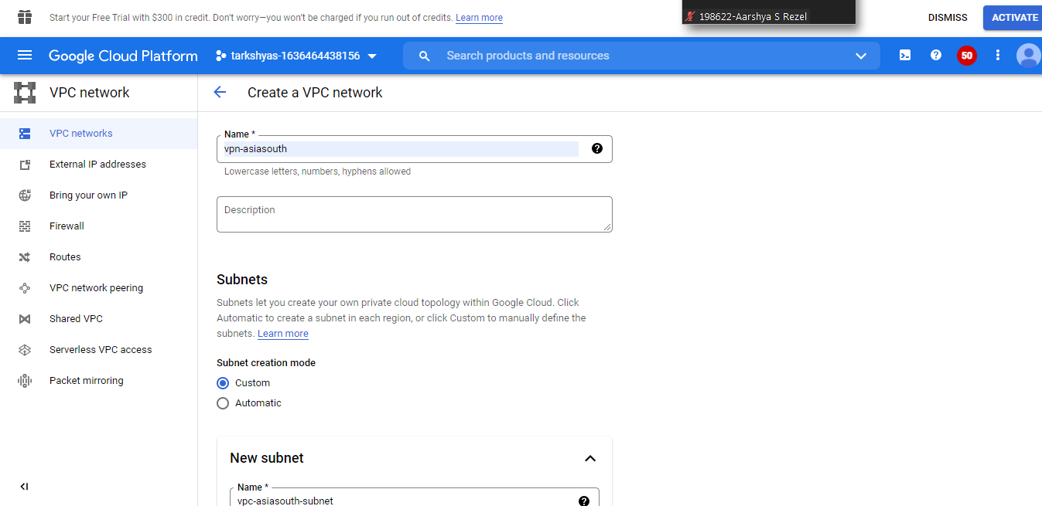

* Create a vpc network having region asia-south
* Similarly create another vpc network having region us-central

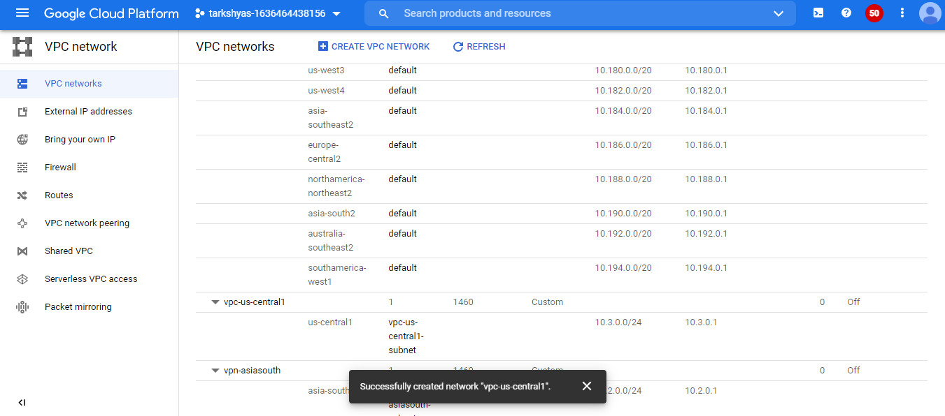

* Add firewall rule for each vpc network

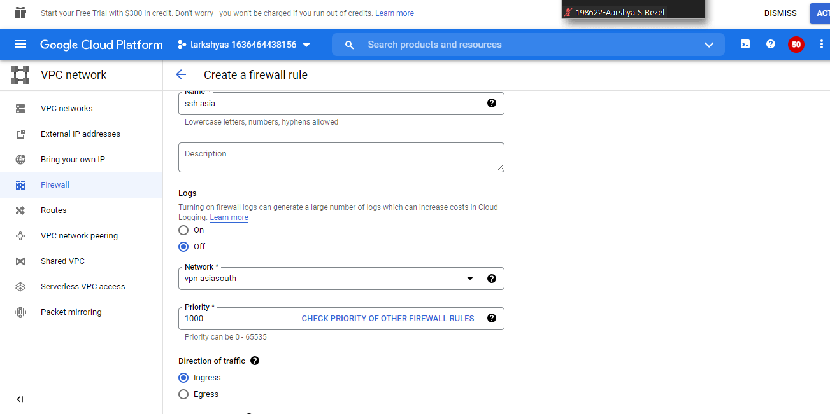

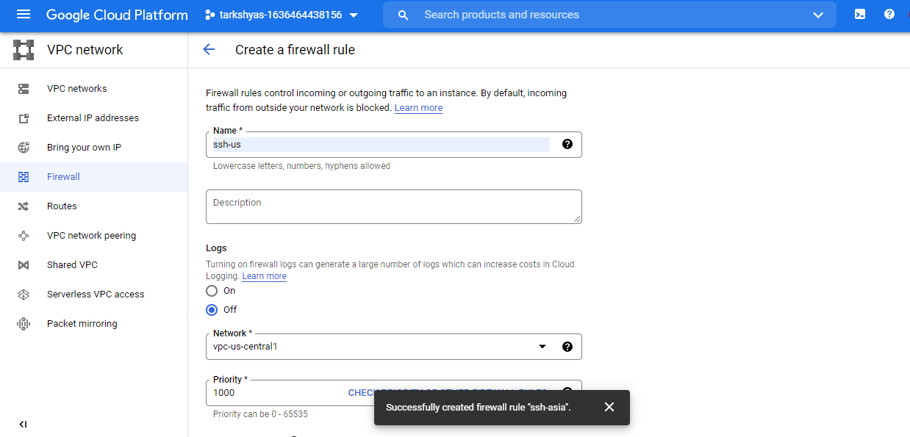

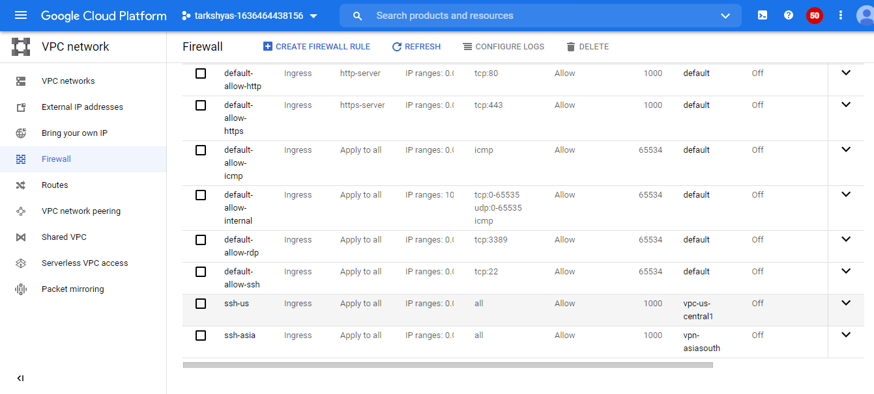

* Now Create 2 Different region VM instances using vpc network

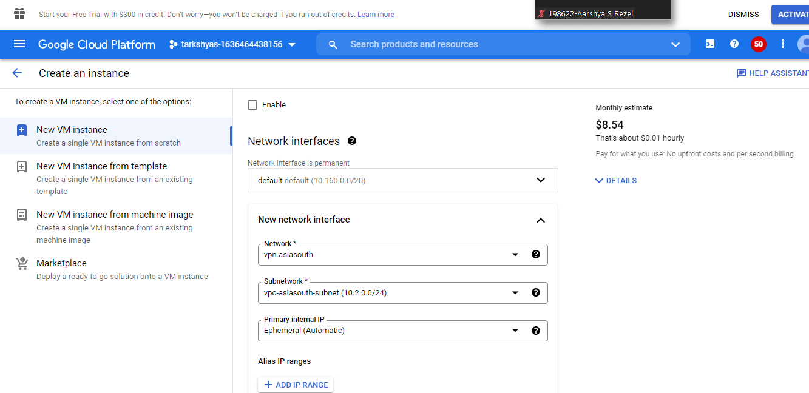

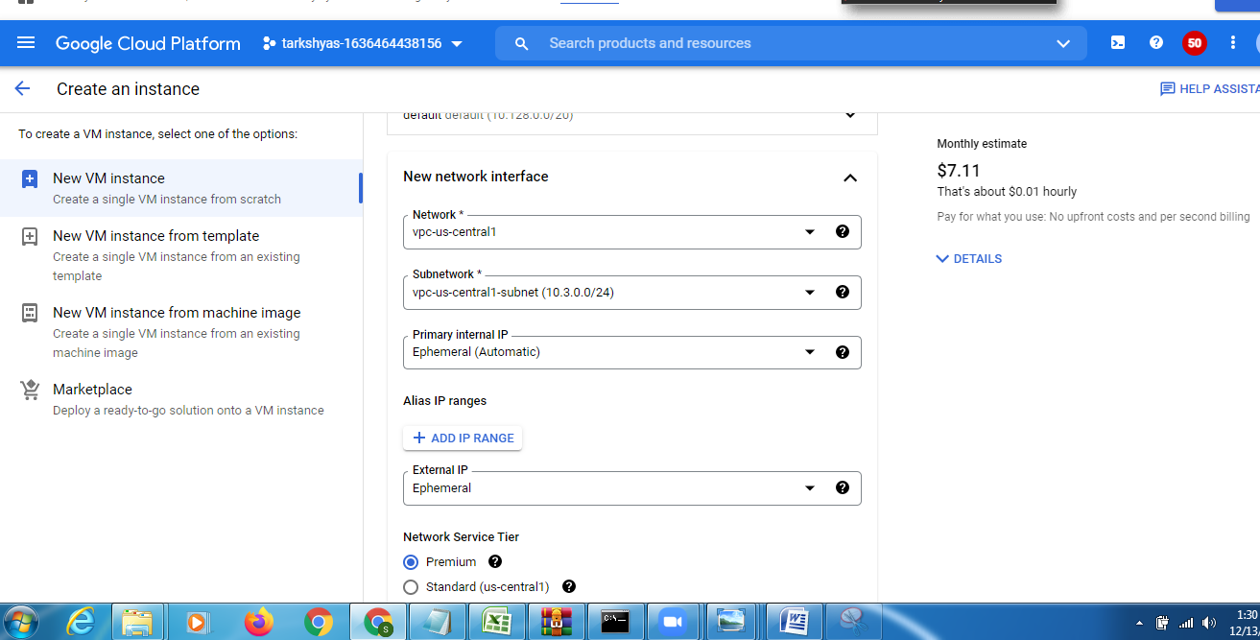

* For connection between these two vm we create VPN connection

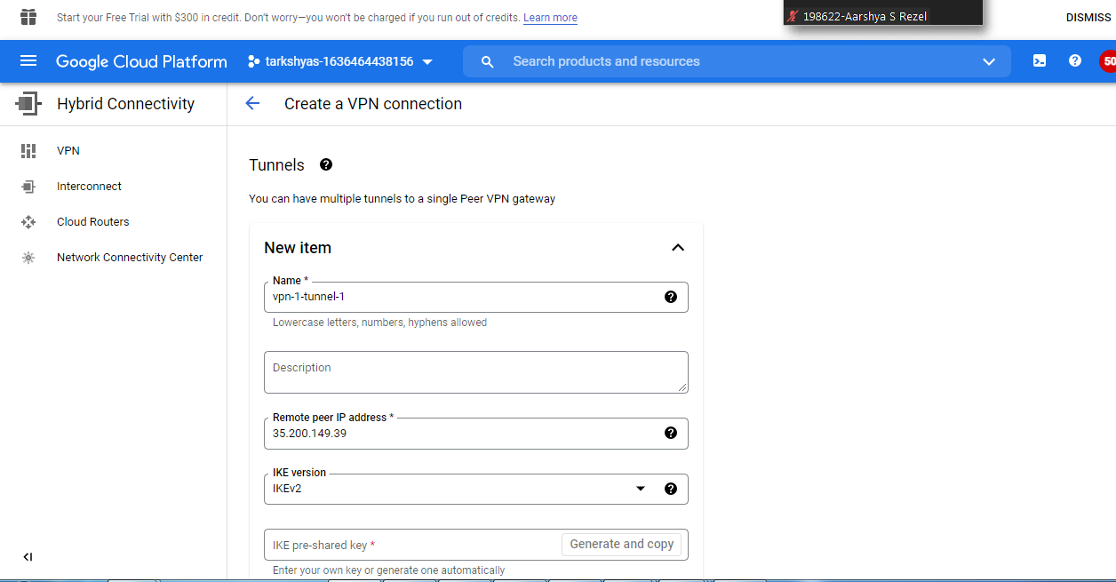

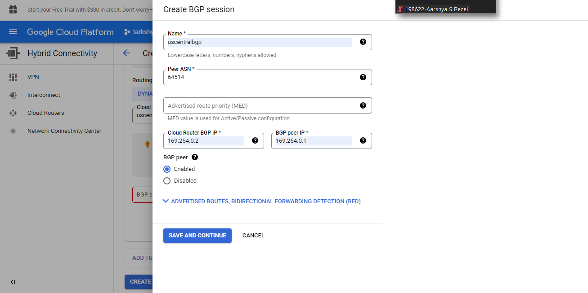

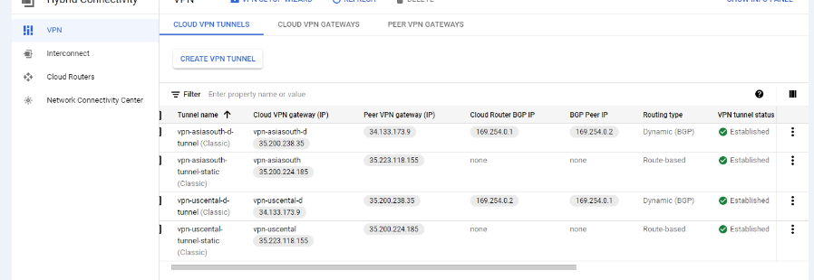

* We can create vpn connection using both dynamic and static method
* Connection will established on both method
* Now in SSH if we ping the network using command

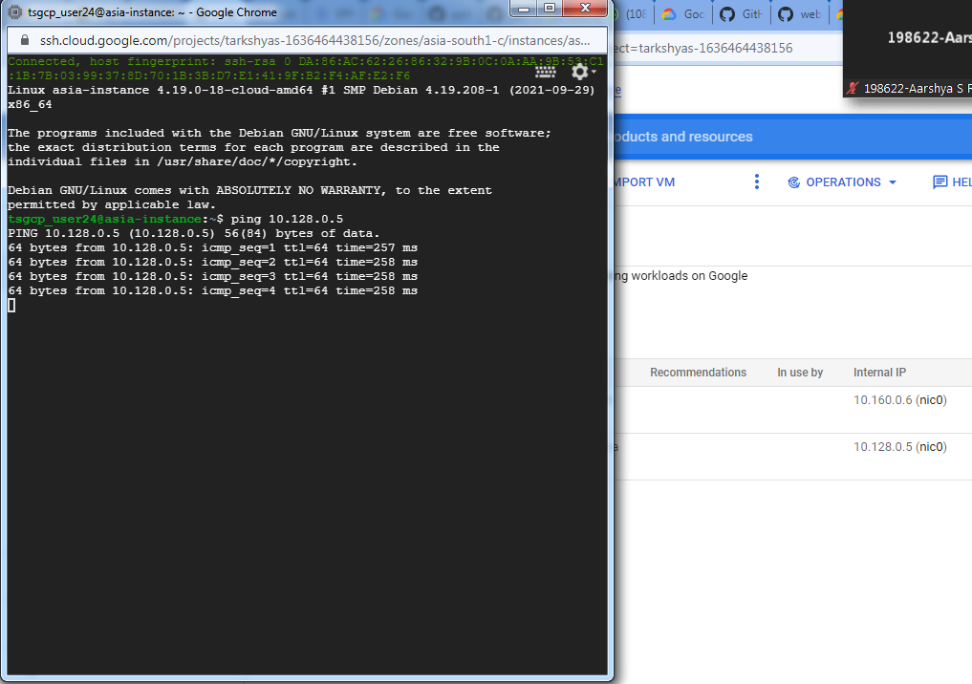

**Q5) Create a Cloud Function to host a http function**

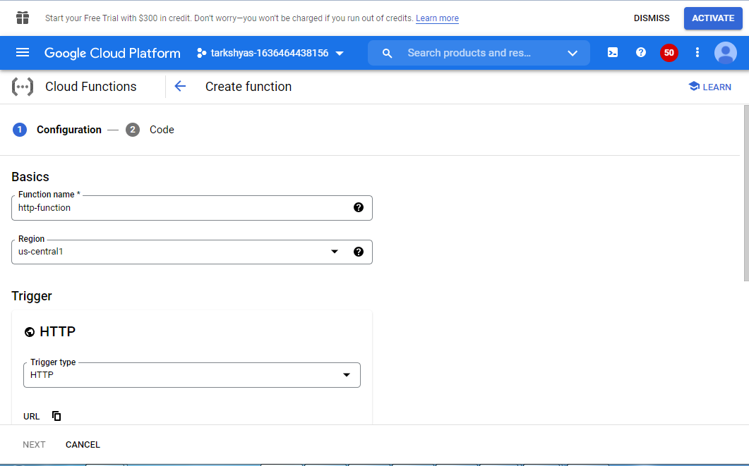

* Navigation 🡪 Cloud Function 🡪Trigger 🡪 http
* Open the Functions Overview page in the Cloud Consol
* Make sure that the project for which you enabled Cloud Functions is selected.
* Click **Create function**.
* Name your function.
* In the **Trigger** field, select **HTTP**.
* In the **Authentication** field, select **Allow unauthenticated invocations**.
* Click **Save** to save your changes, and then click **Next**.
* In the **Source code** field, select **Inline editor**. In this exercise, you will use the default function provided in the editor.
* Use the **Runtime** dropdown to select the desired Python runtime.

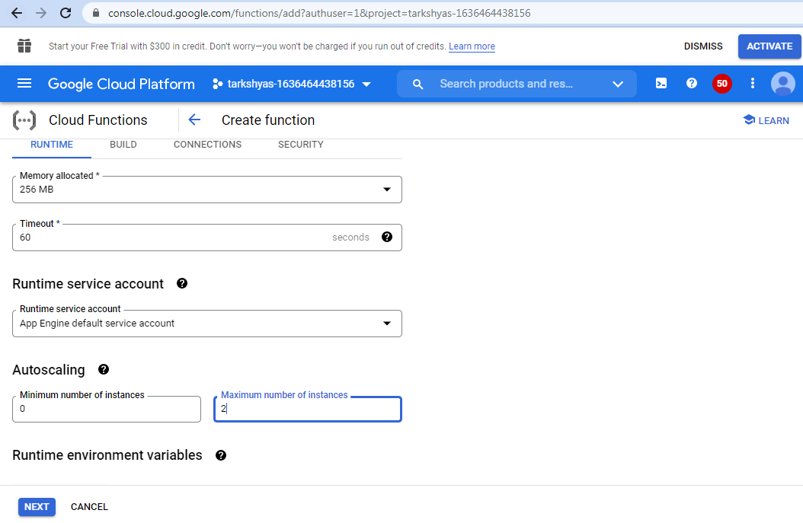

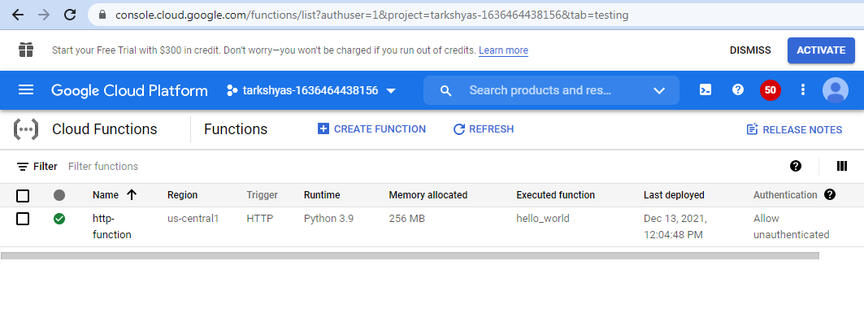

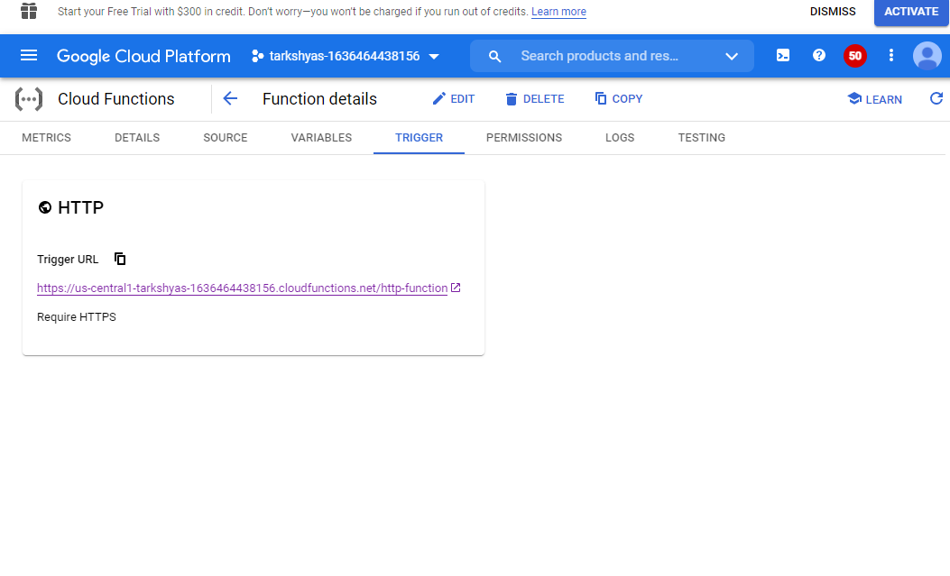

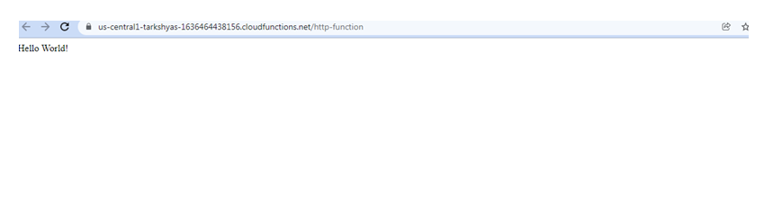

**Q6) Cloud Run**

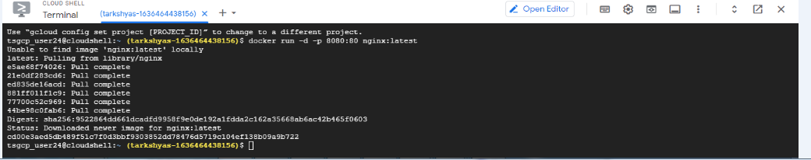

* Initially a container is created and the file are copied to the container

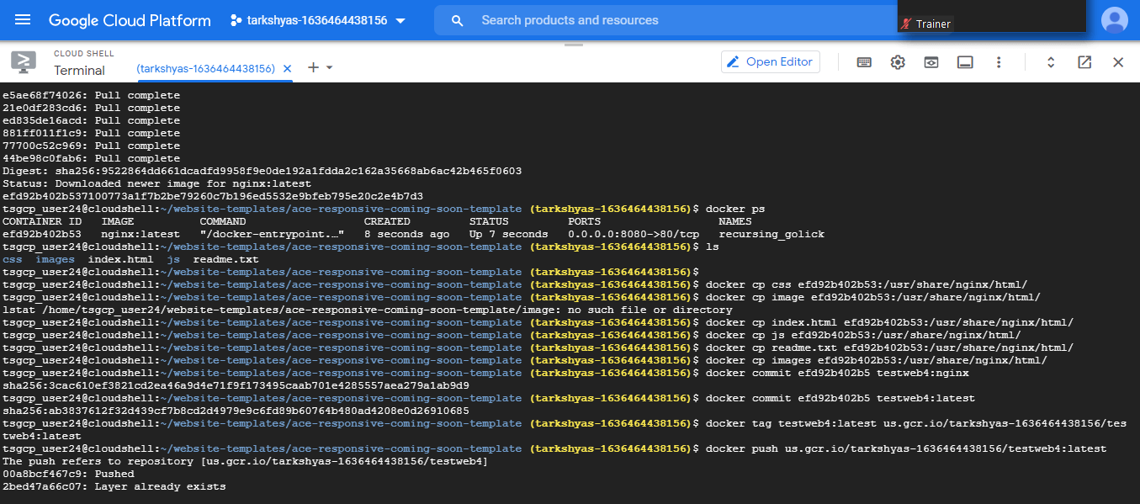

* **URL: https://github.com/learning-zone/website-templates**
* the file copied is tag and push to the container using docker command
* Then in cloud run create new service
* Select container image path
* After creating service, Click on the Image URL to goto the webpage.

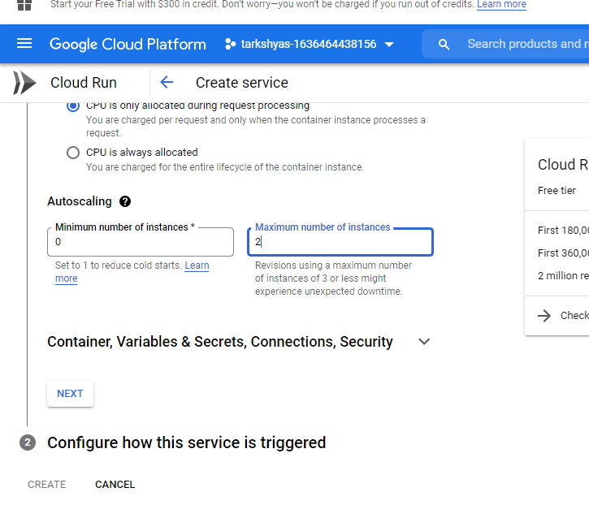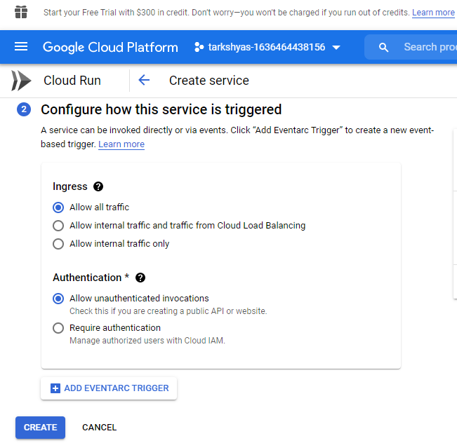

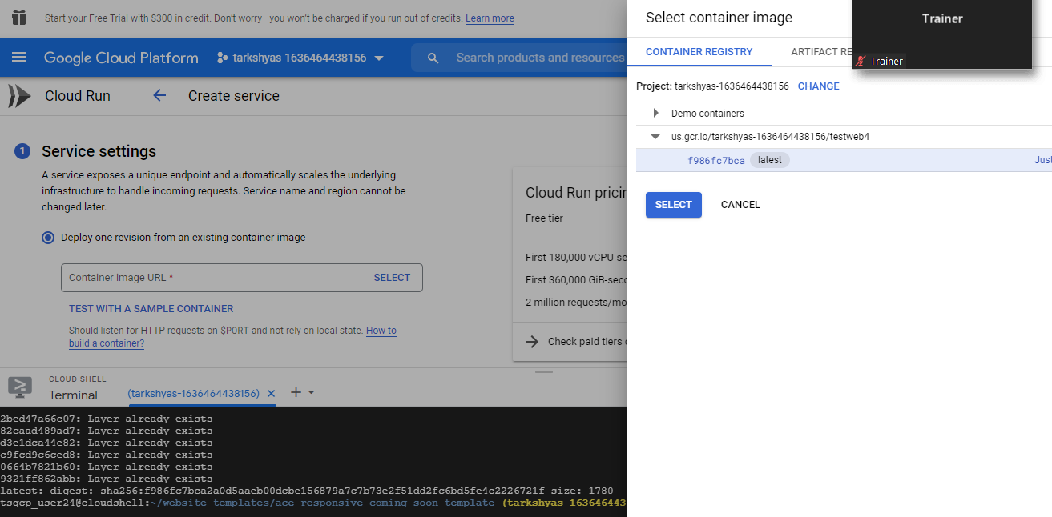

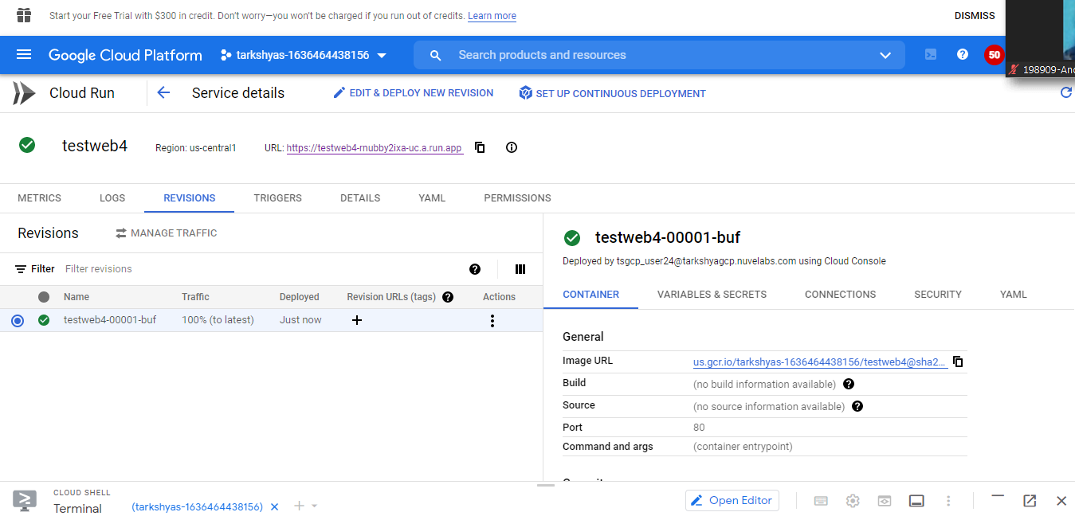

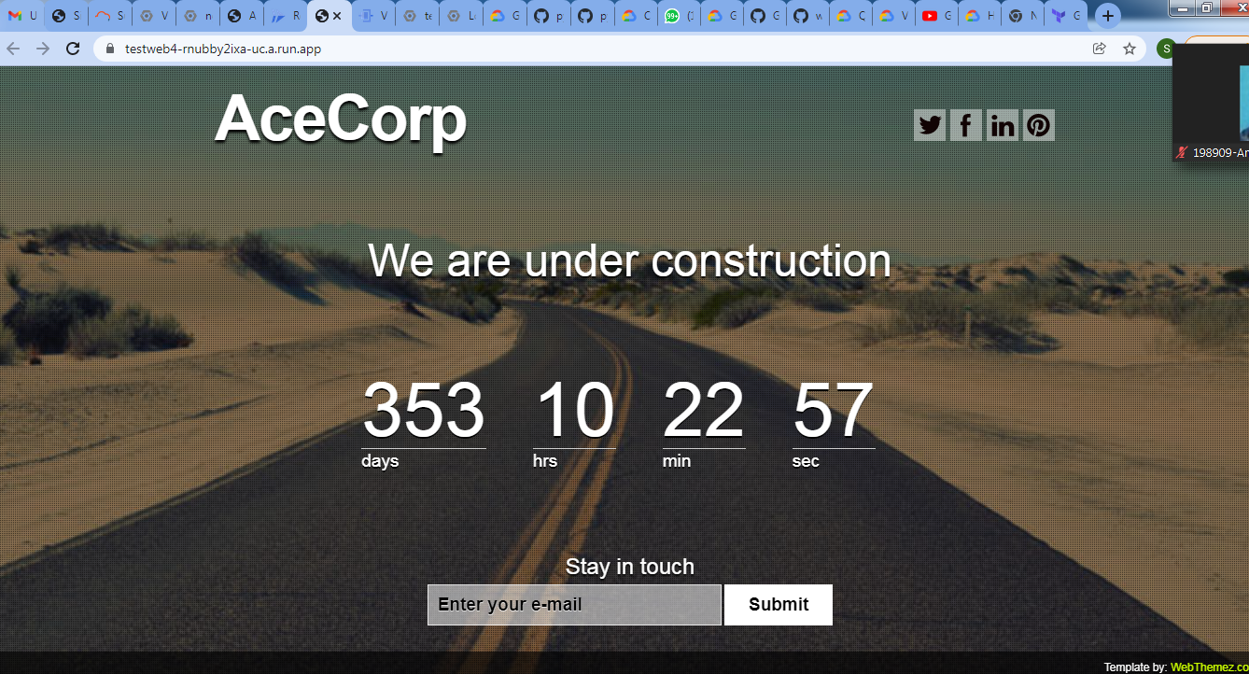

**Q7 ) VPC Peering**

* First create 2 vpc network from : Navigation🡪 VPC network 🡪 Create VPC network

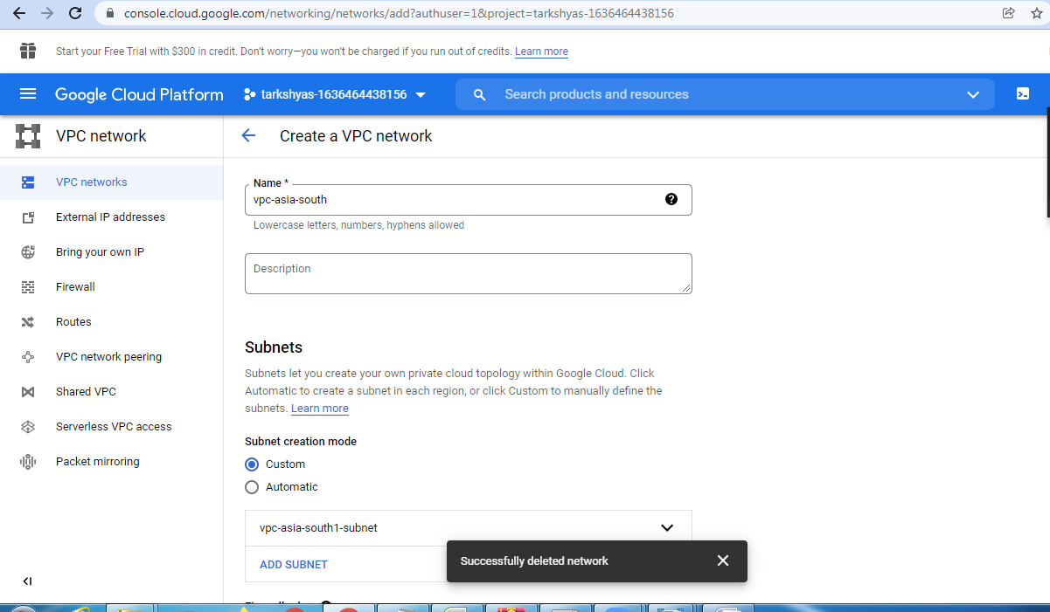

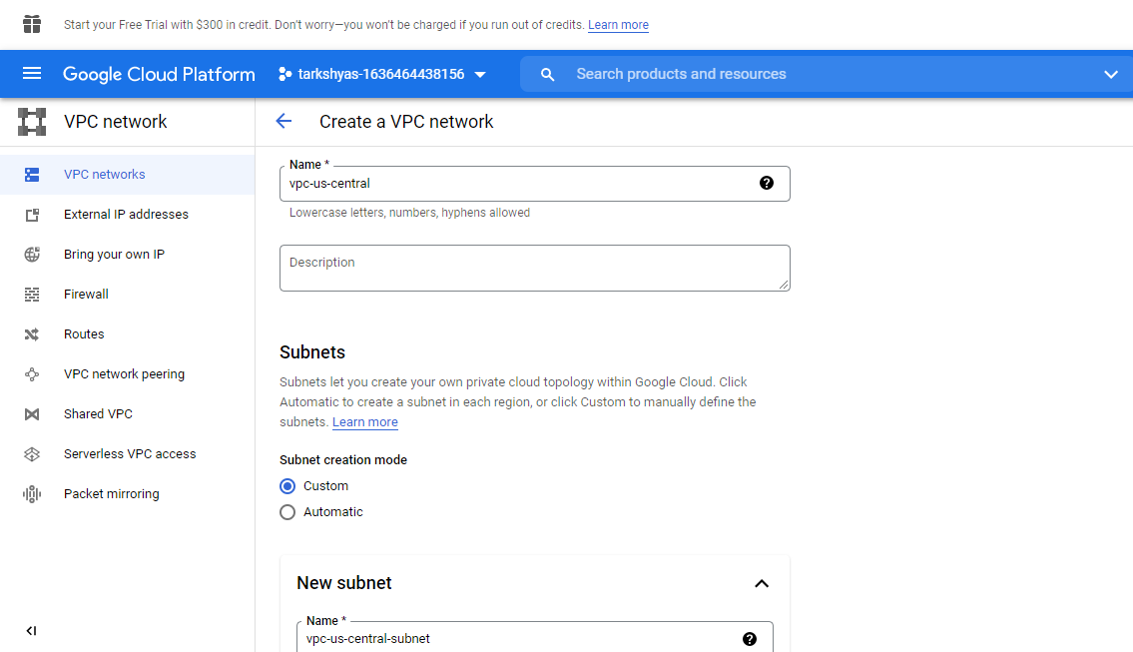

* Create VM instance using created VPC network by adding Network interface.

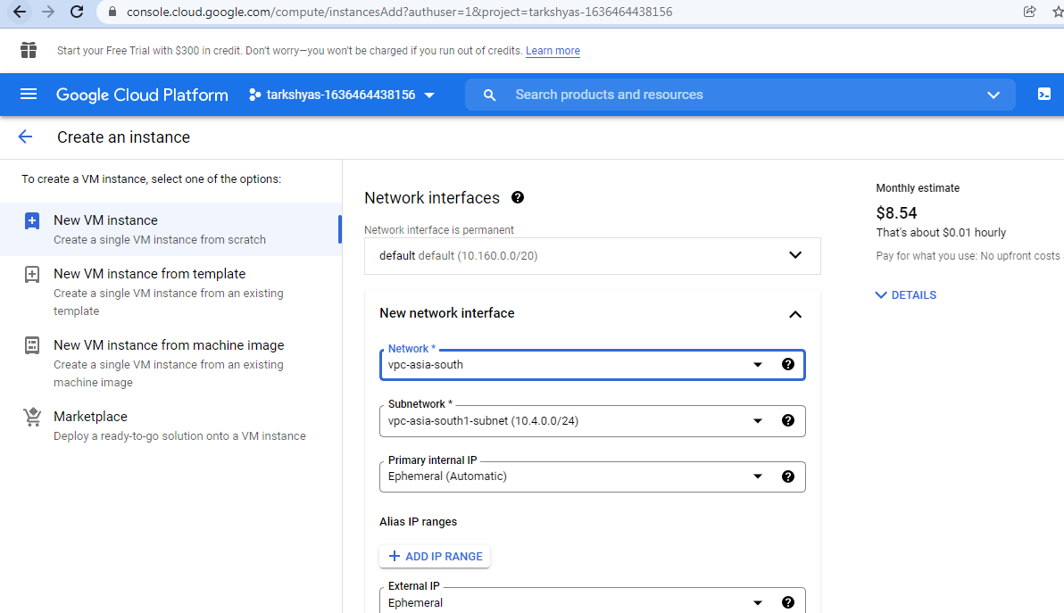

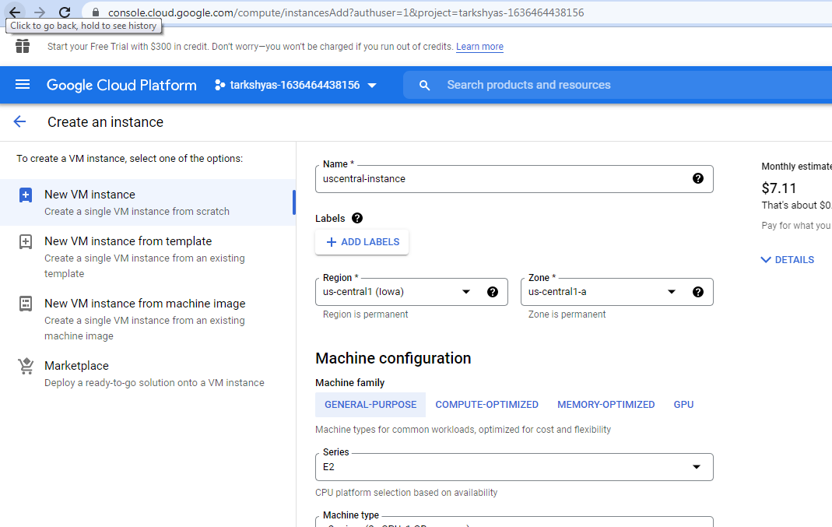

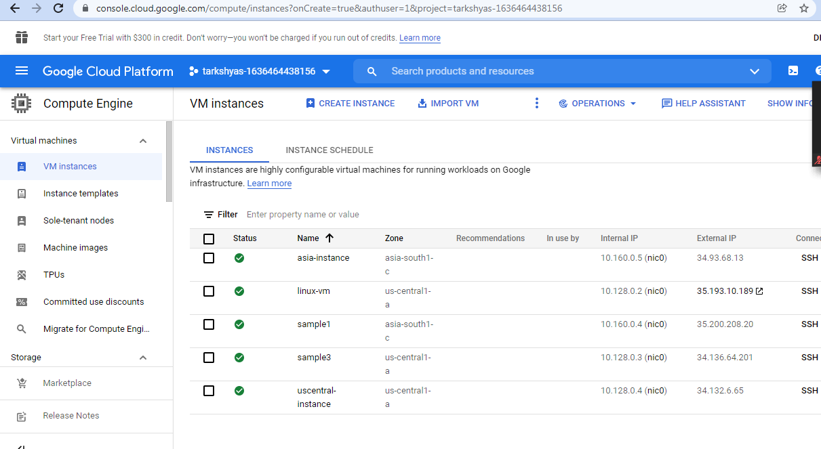

* Now create a network peering from:

🡪Navigation 🡪vpc network 🡪vpc peering 🡪 create peering for both region.

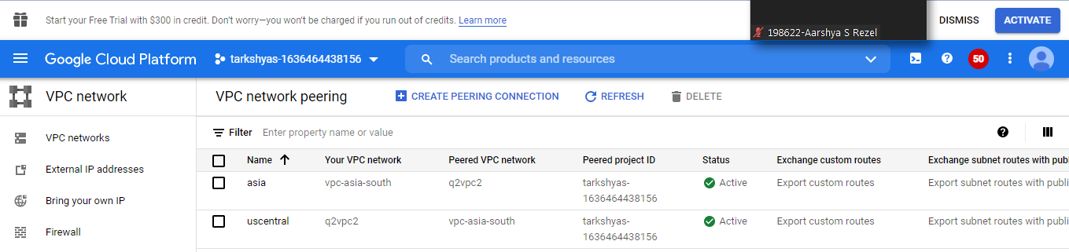

* Ping the VM for peering

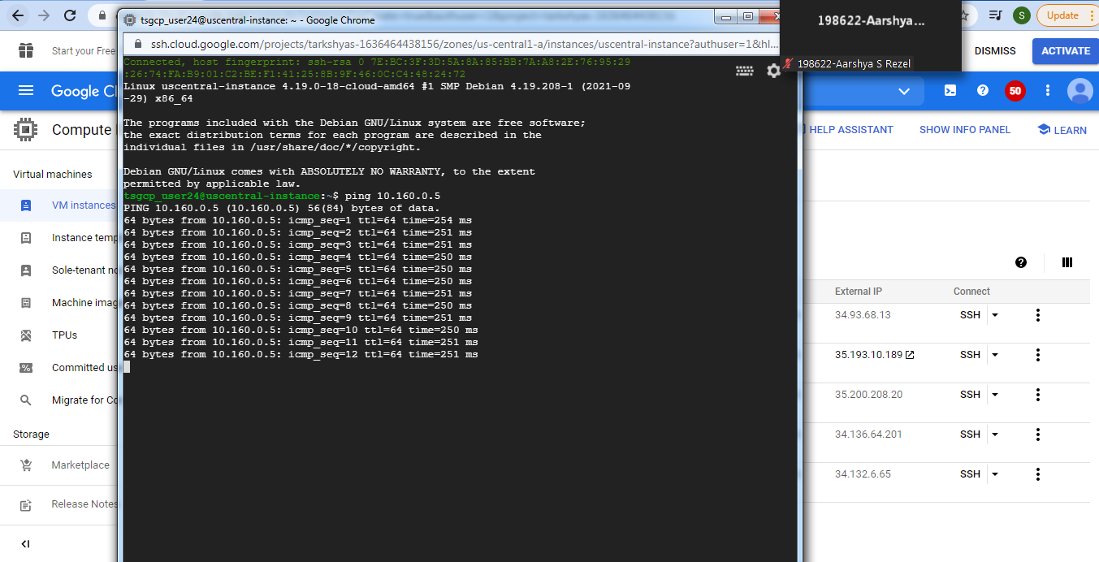

**Q9) Load Balancing**

**HTTP:**

* Navigation 🡪 Network Service 🡪 Load balancing

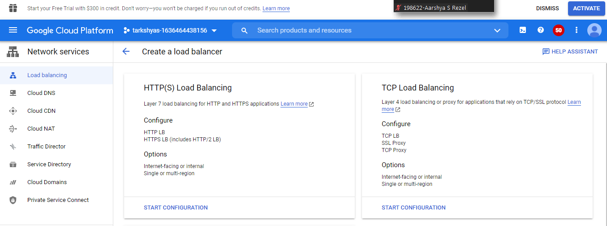

* Create Http Load Balancing

🡪 First create 2 insatnce and make a group

🡪Create Instances template for load balancing

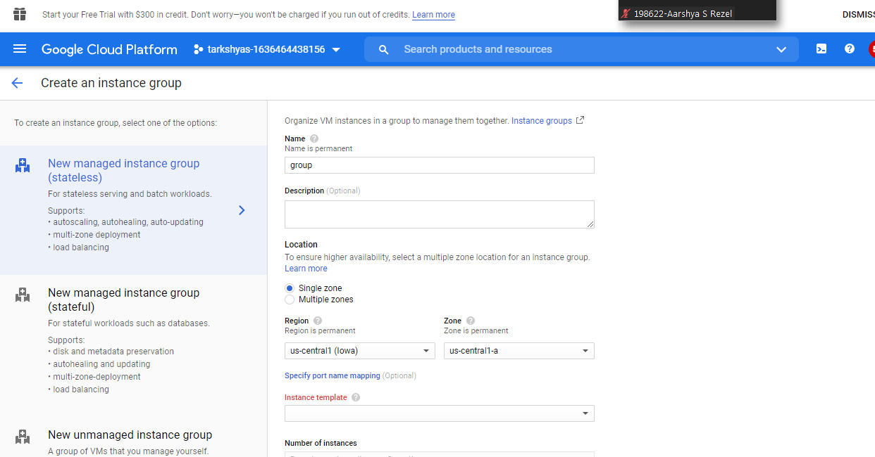

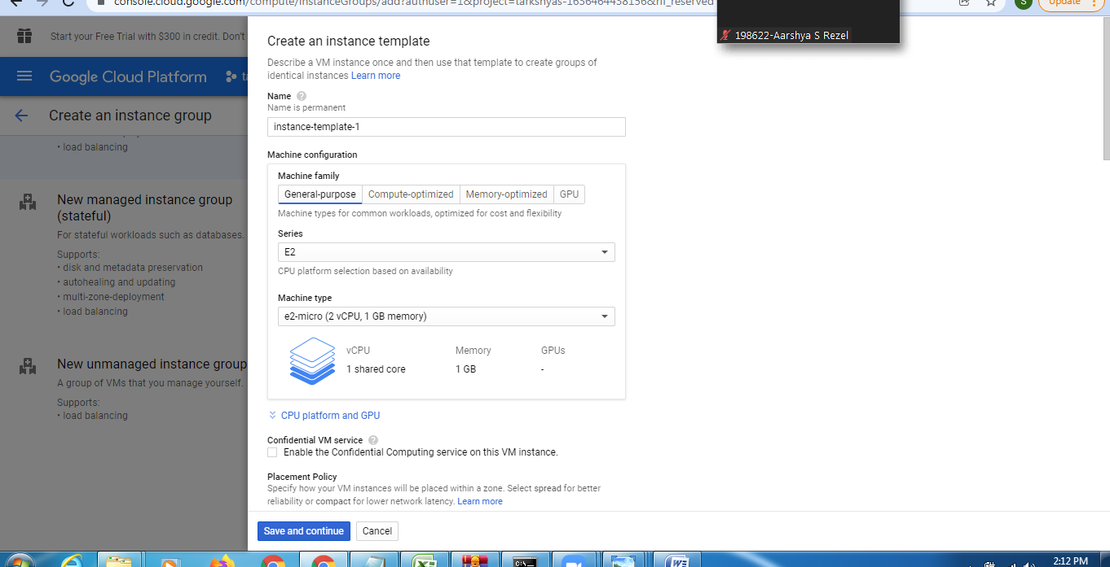

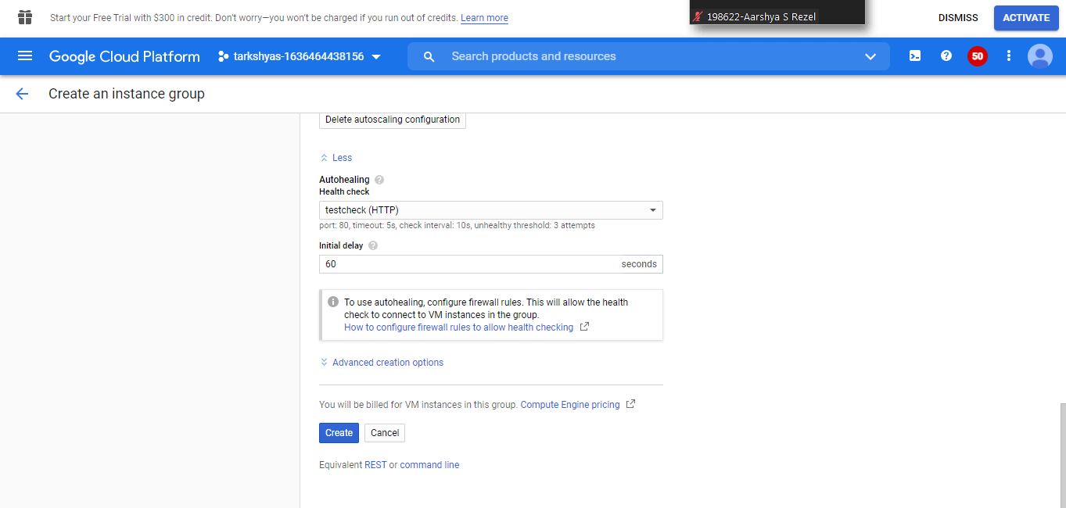

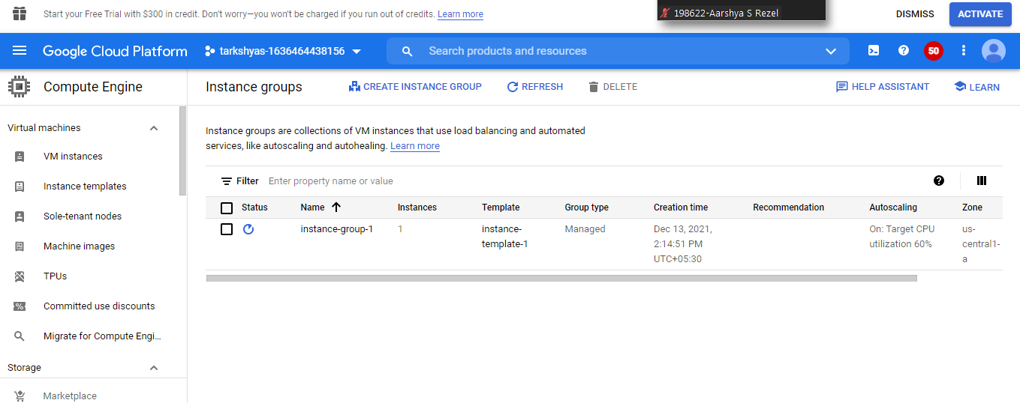

🡪Create backend service and frontend Configuration:

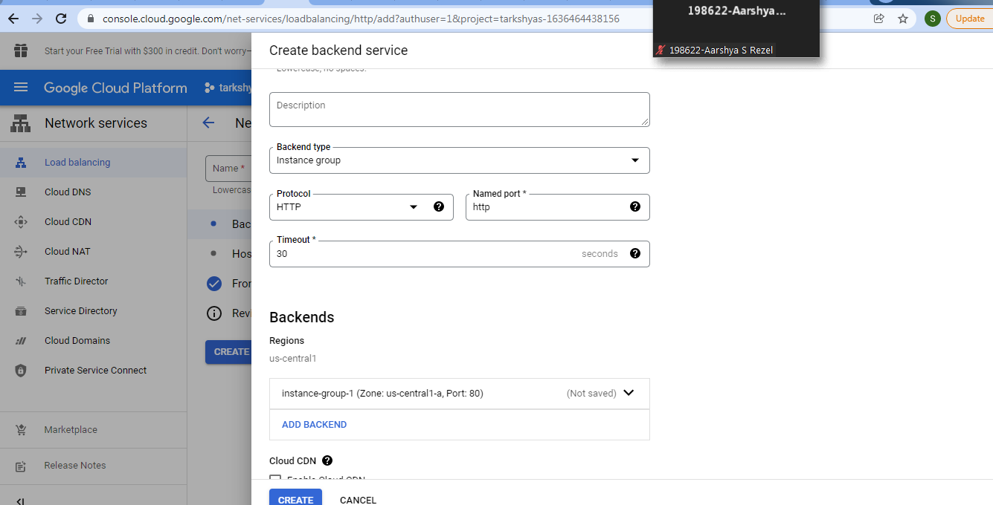

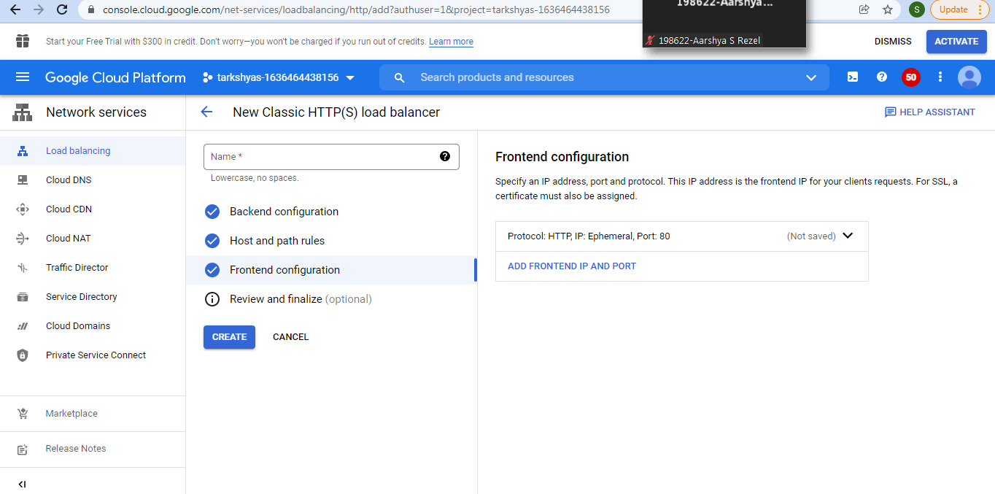

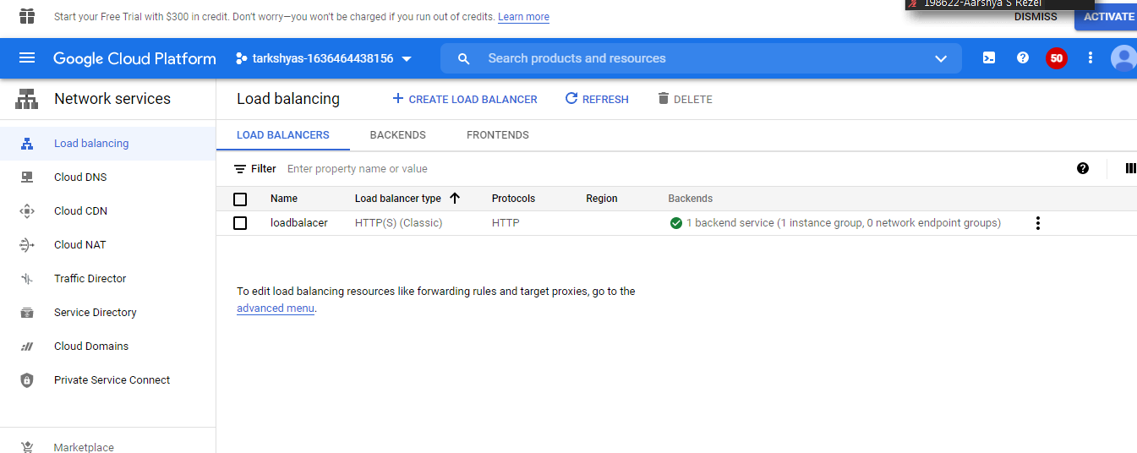

* By click on external Ip of instances we can see the loadBalancing message. It will allocate to other vm instance when over load occure.

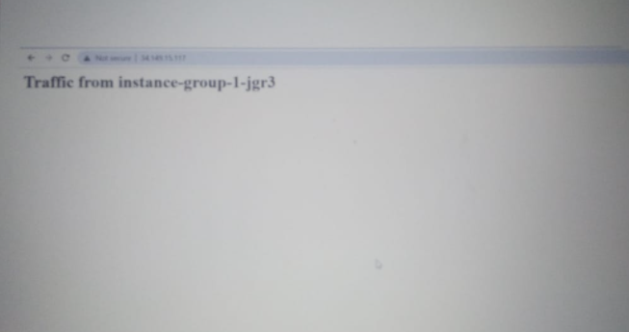

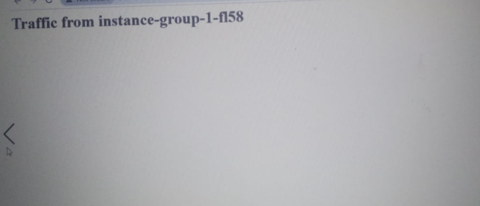

**TCP Load Balancing:**

* Similarly we can create Tcp Loadbalancer for Vm:

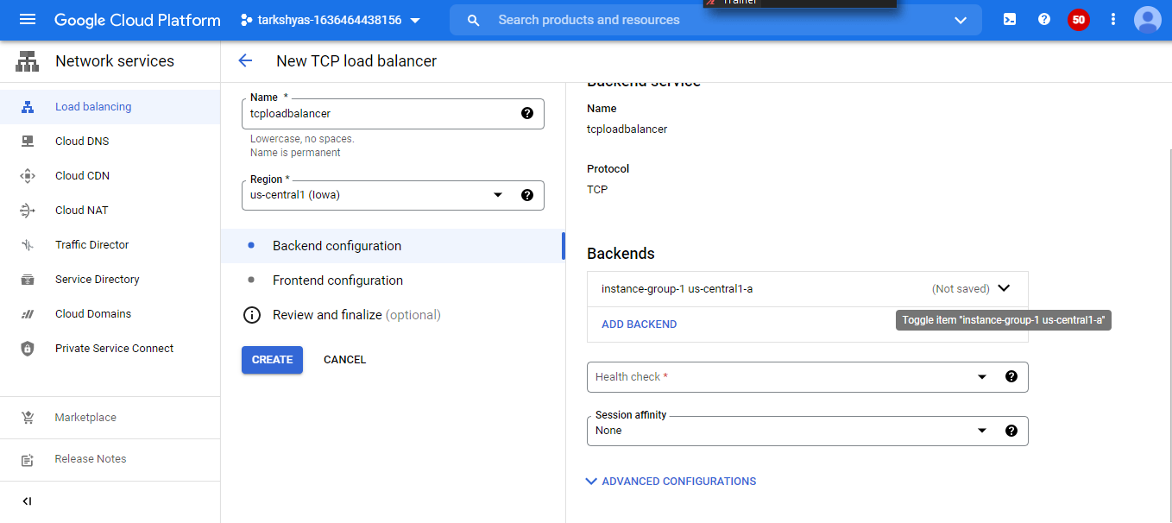

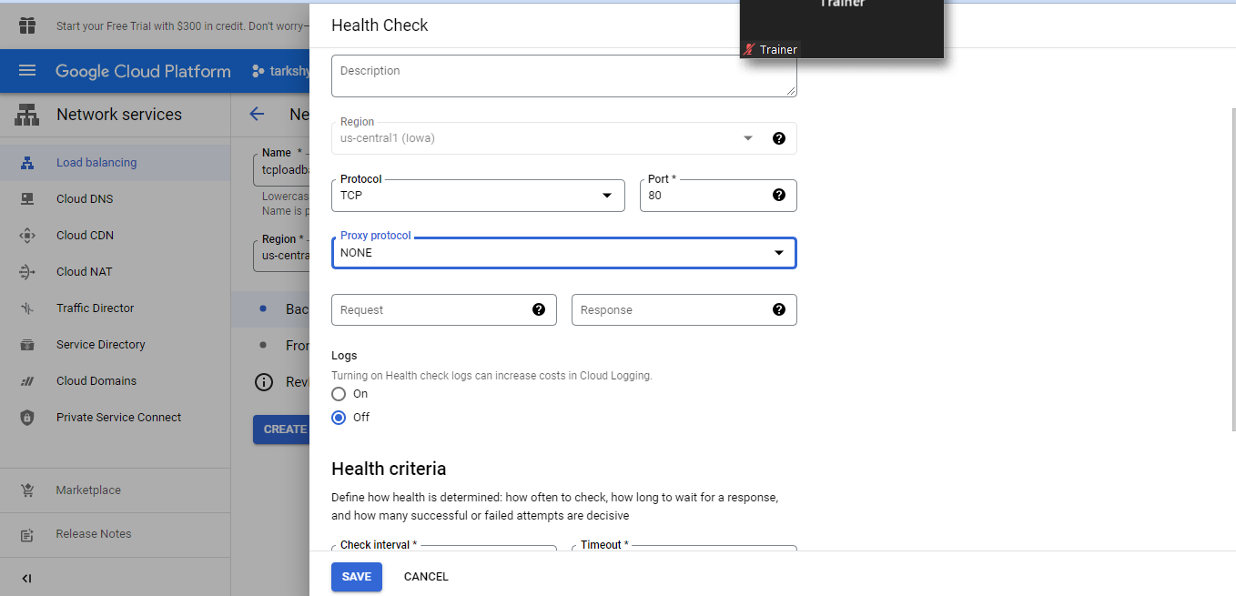

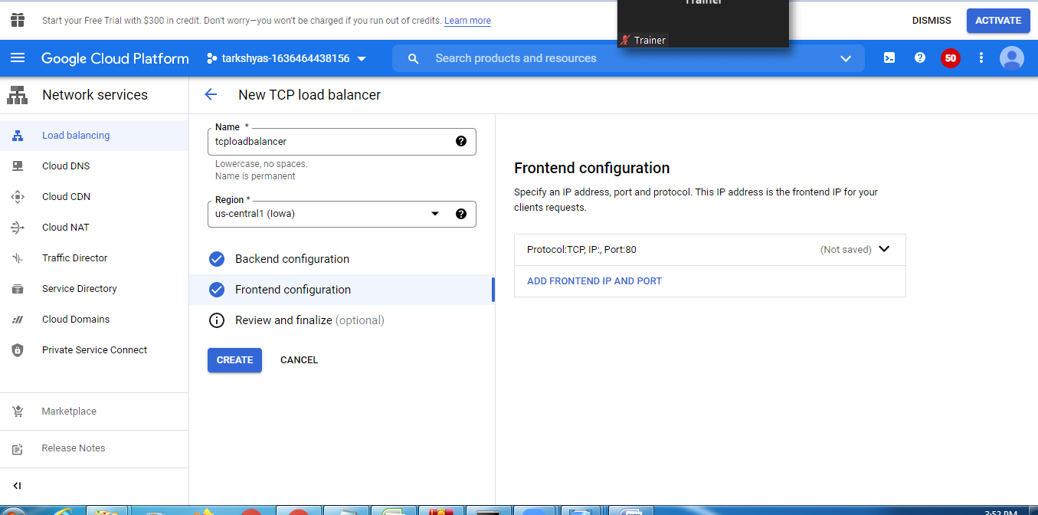

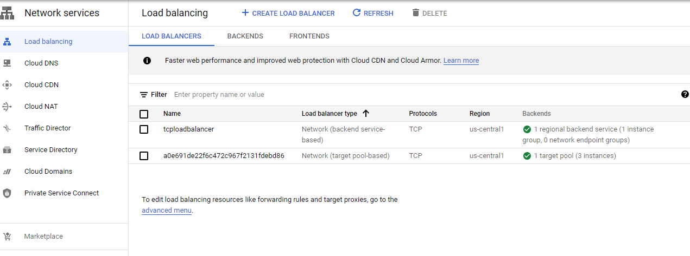

**Q10) GKE(Google Kubernetes Engine):**

* Navigation menu🡪 kubernates 🡪 deploy kubernates

🡪 Initially copy the website files into a docker container using docker command in cloud shell

🡪URL : https://github.com/learning-zone/website-templates

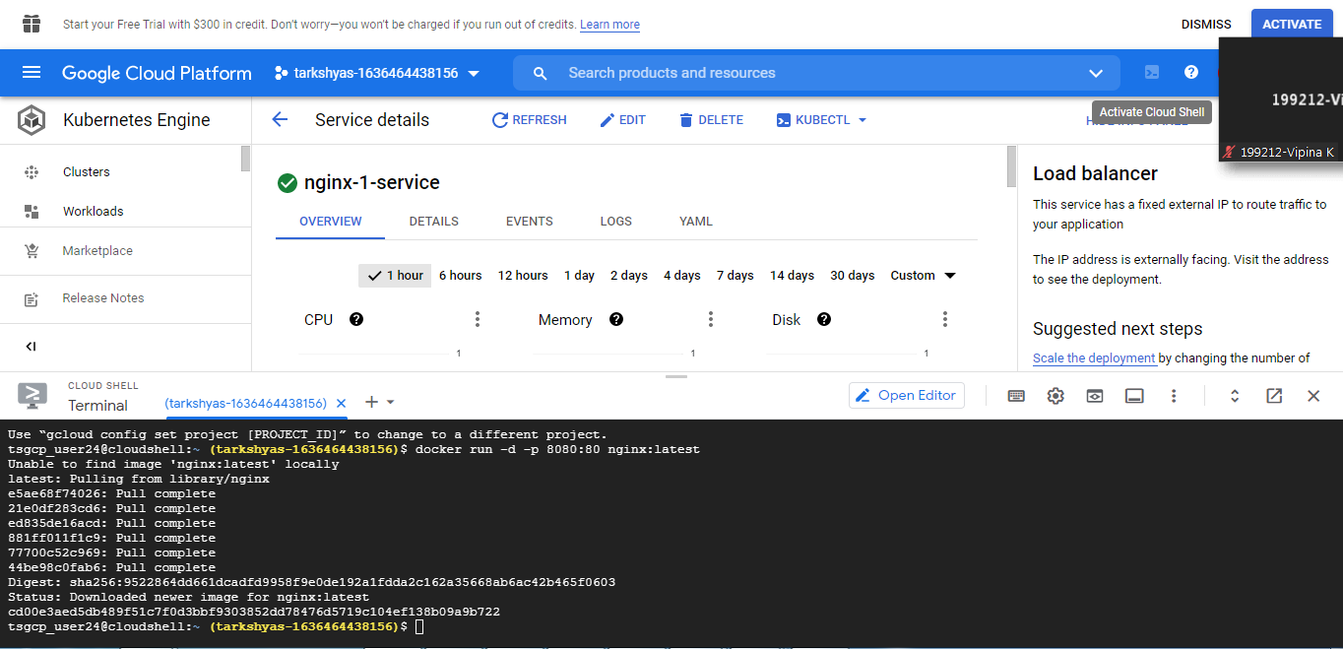

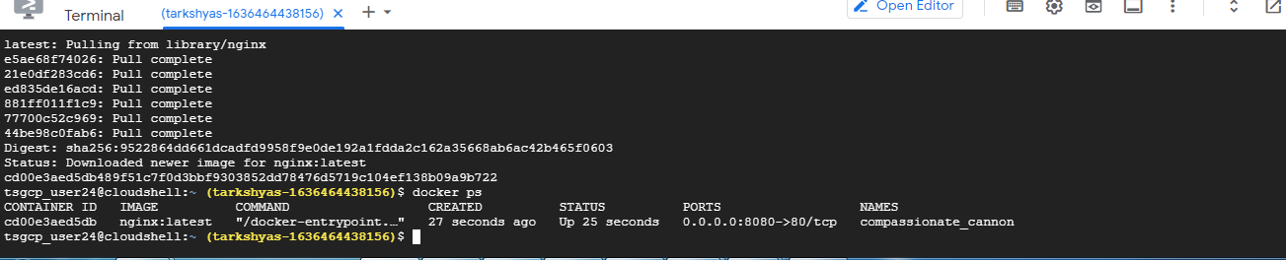

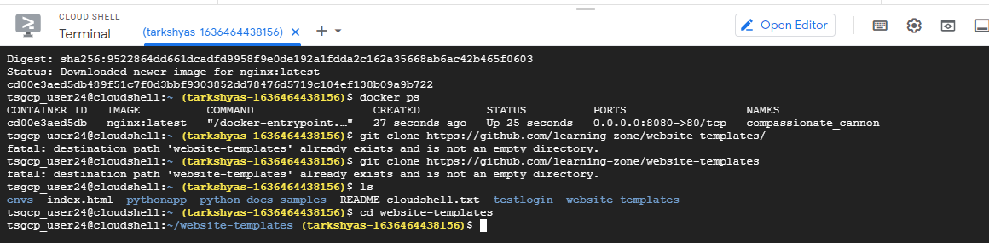

* All files are copied into container using docker cp command
* Then we tag and push the file

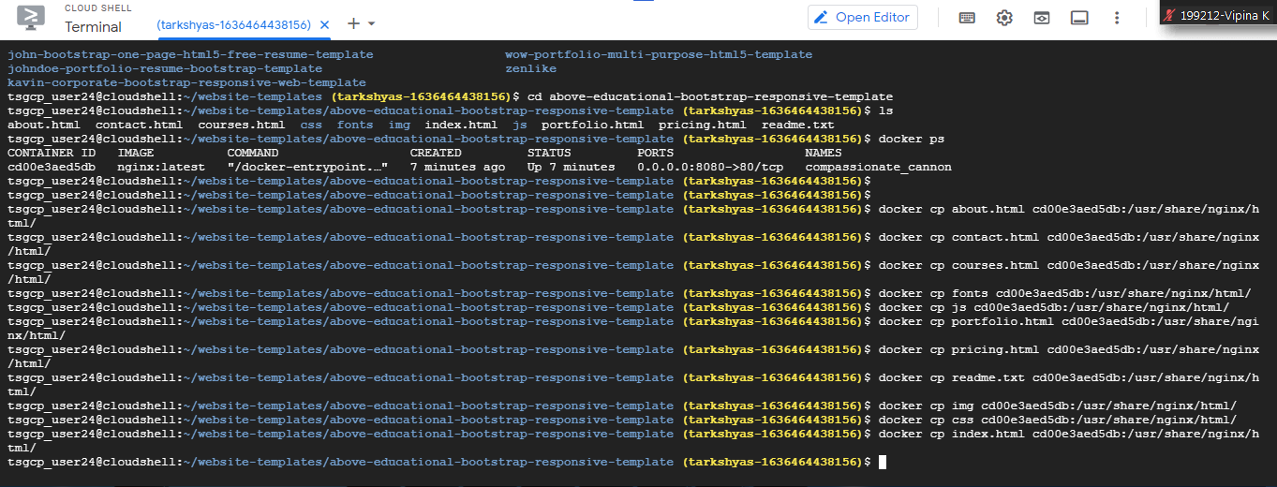

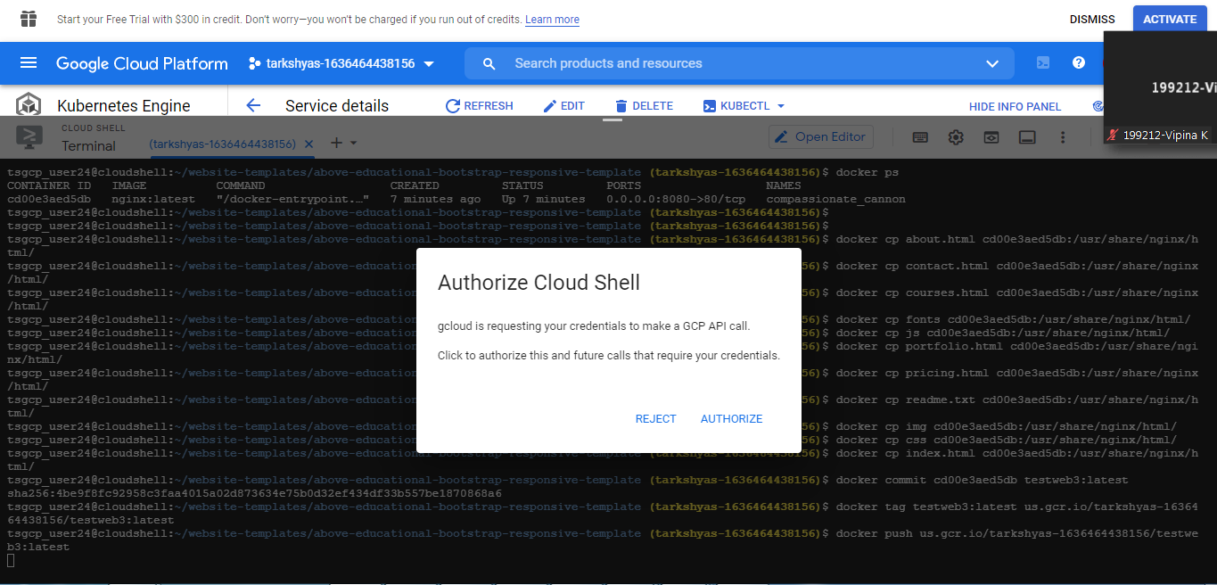

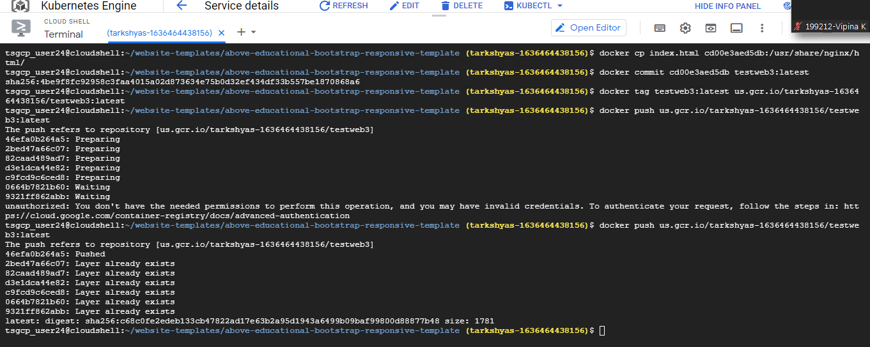

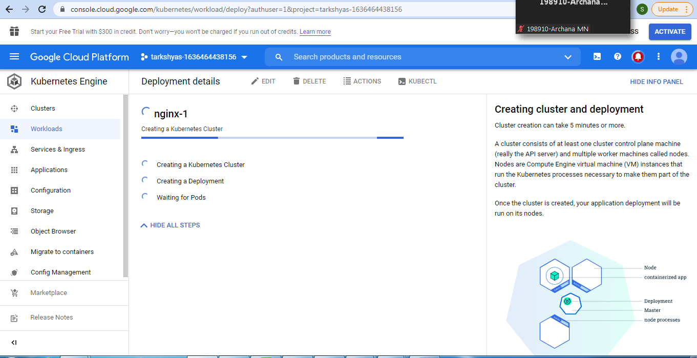

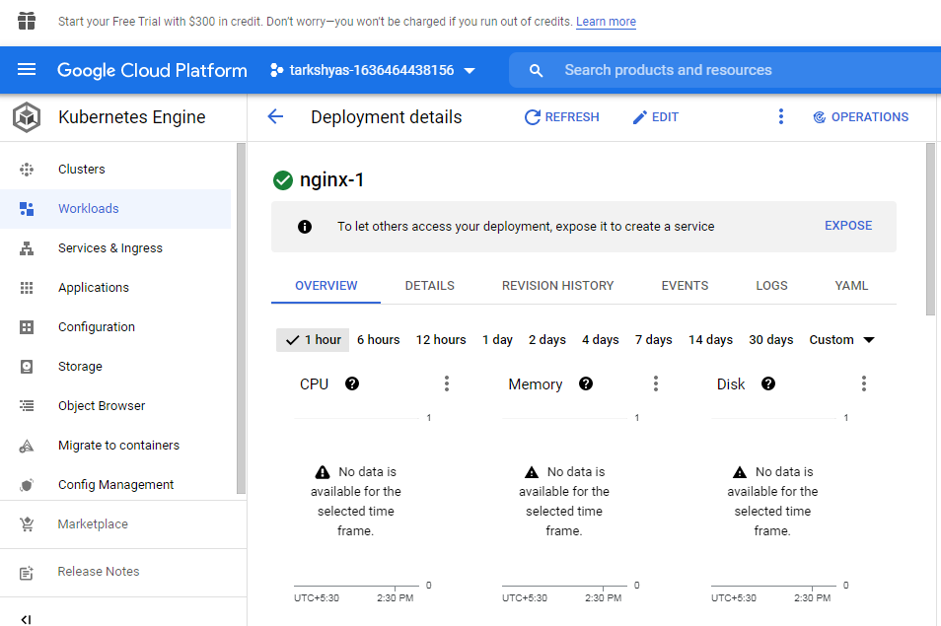

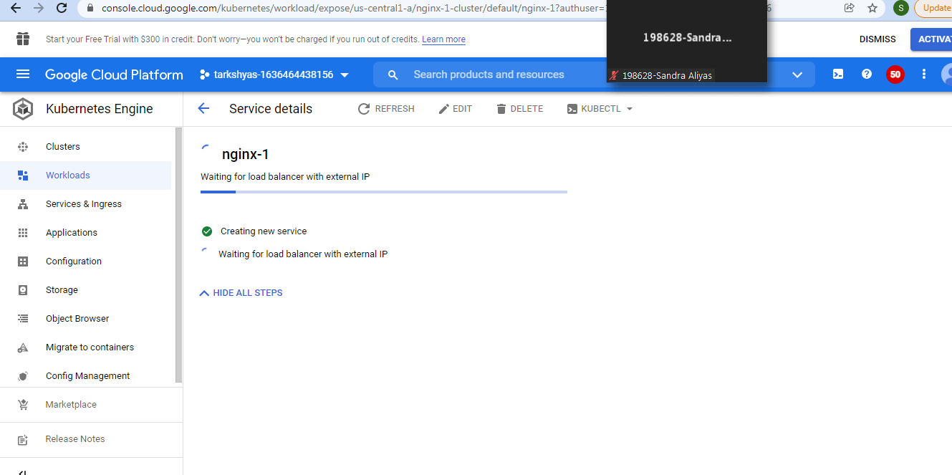

* For viewing the webpage we can click the preview button in the cloud shell:



Q11) **Terraform And Ansible:**

**Terraform:**

🡪first install cloud sdk

🡪Download Terraform

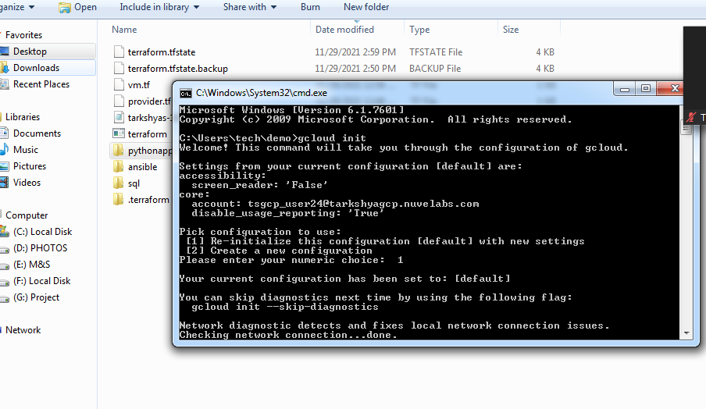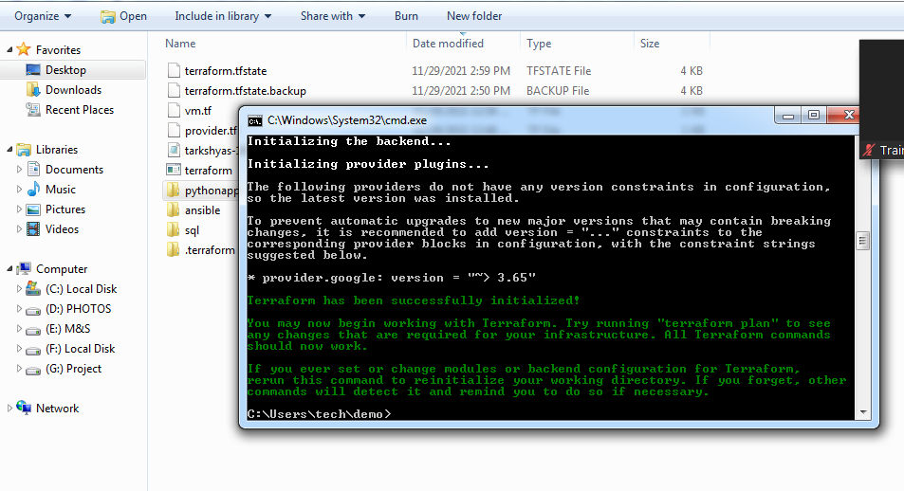

🡪after adding .terraform file and json file in a folder

* Enter command terraform init,terraform plan, terraform apply

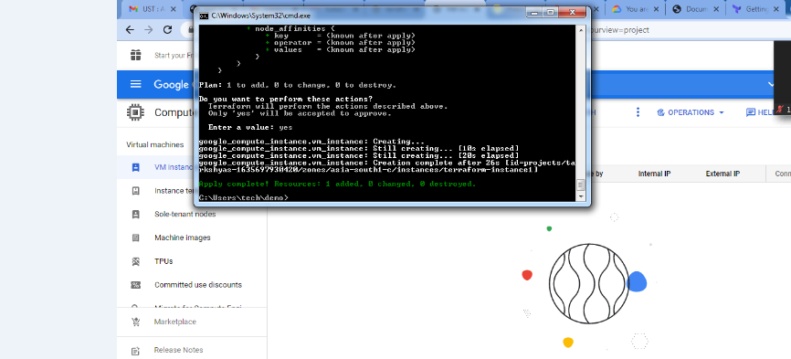

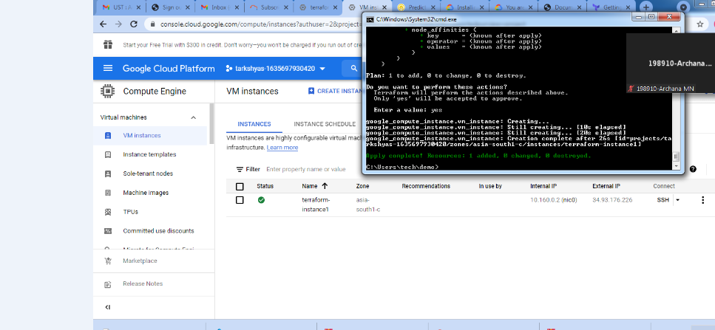

* **TERRAFORM VM IS CREATED IN VM INSTANCES**
* We can also delete or destroy the vm through the cloud sdk by command.

**ANSIBLE:**

* Give IAM Service Permission
* Create new key and download the json file.
* Create a yml file for creating instances
* Add both file in console

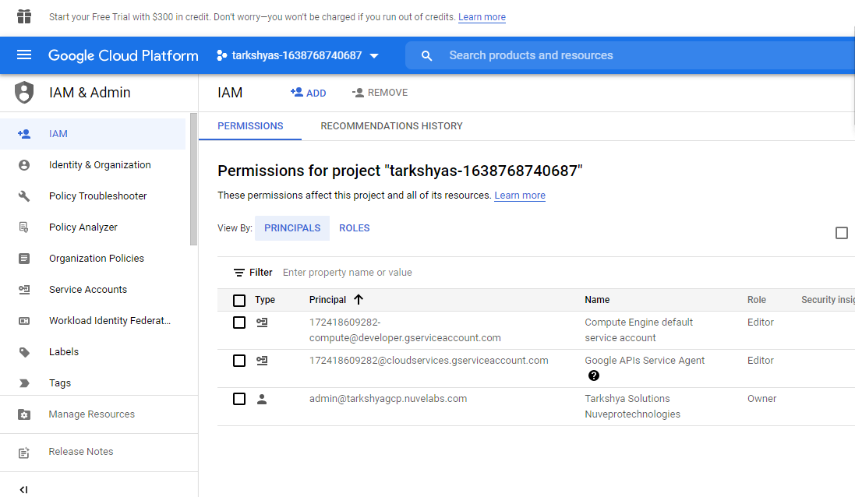

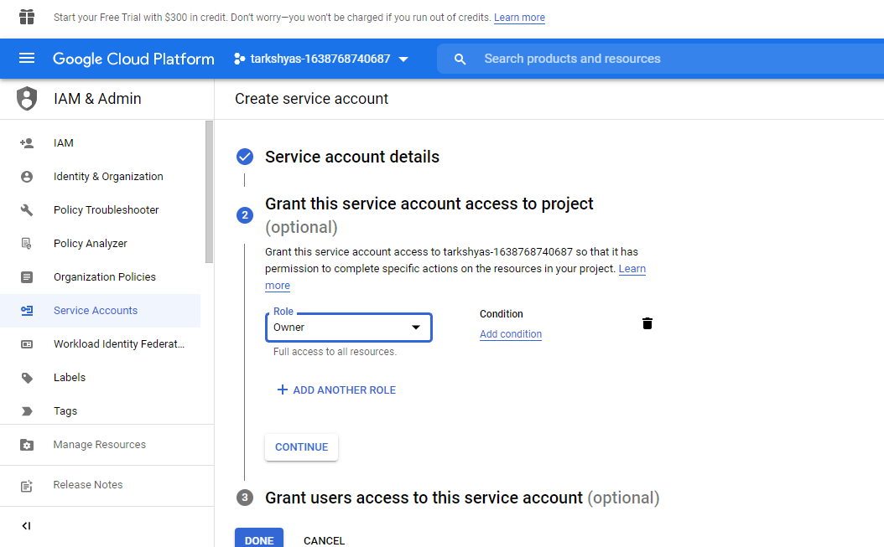

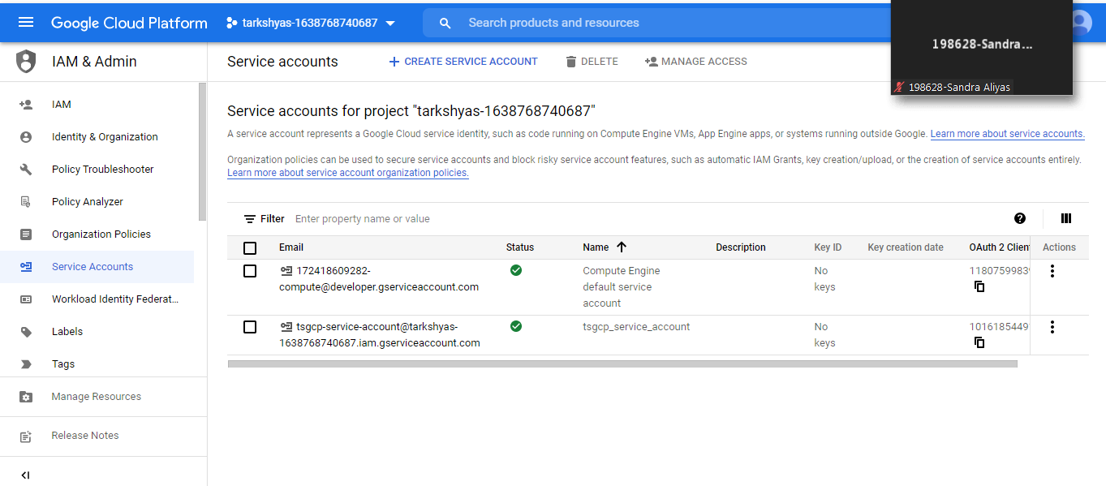

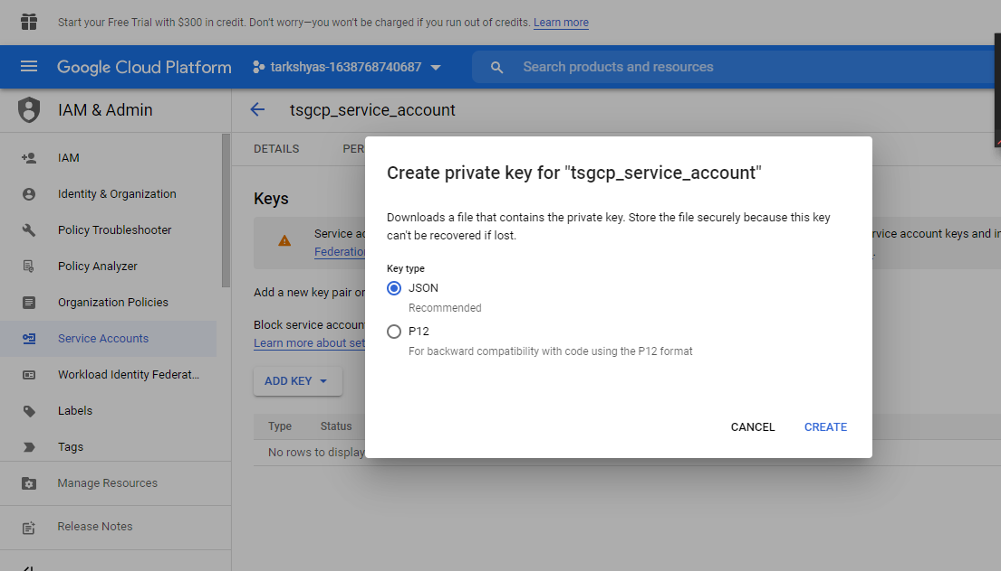

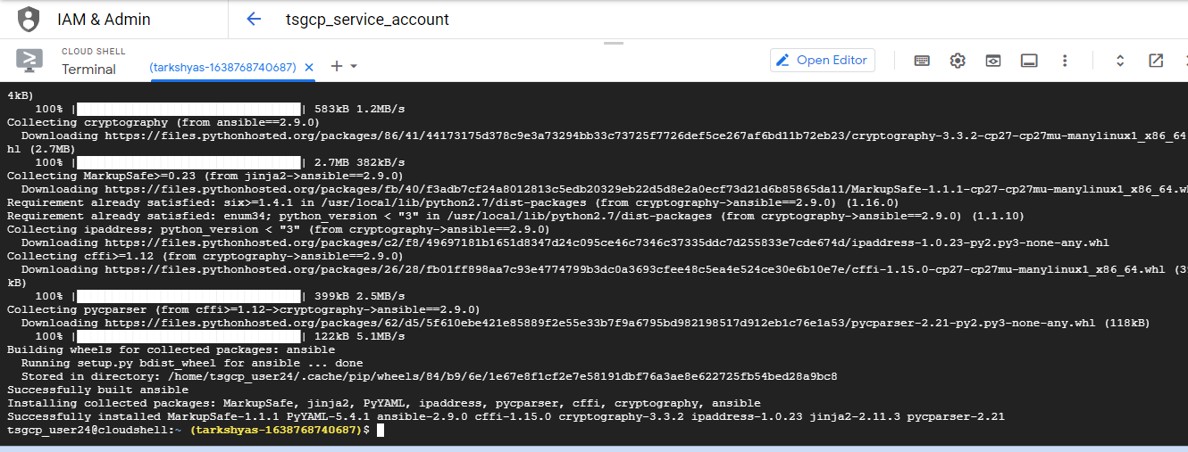

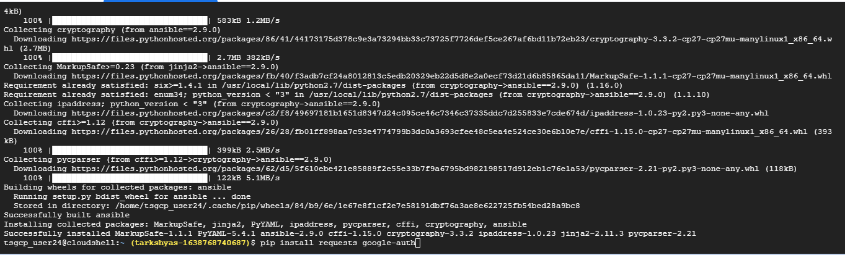

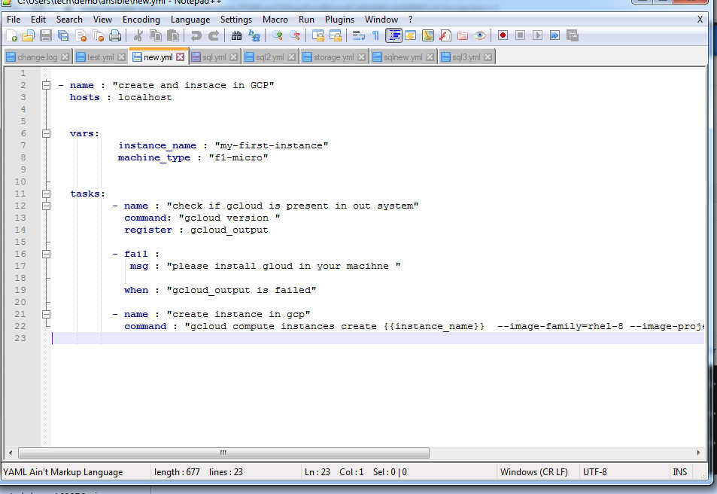

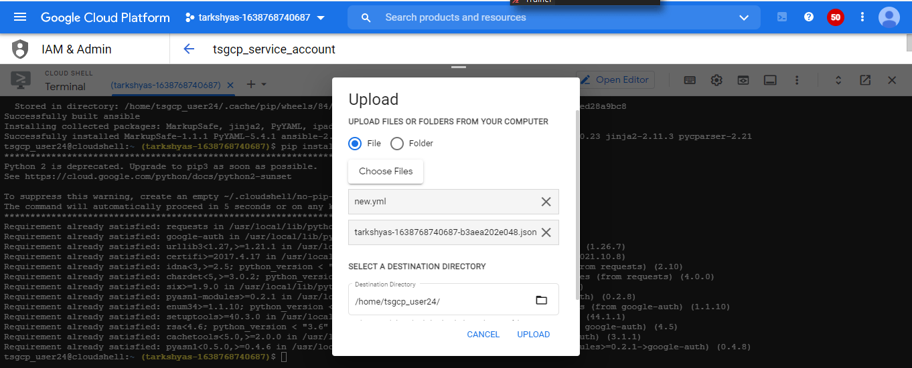

* Enter command ansible-playbook for creating instances using ansible

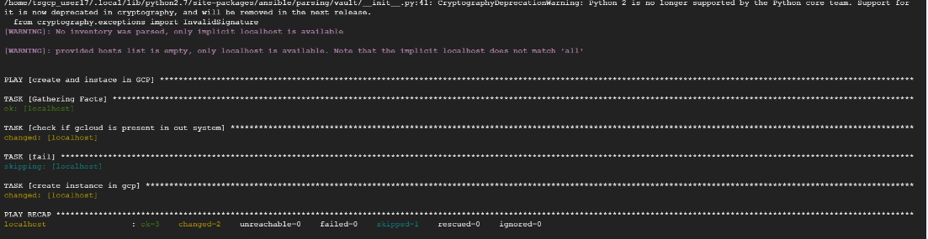

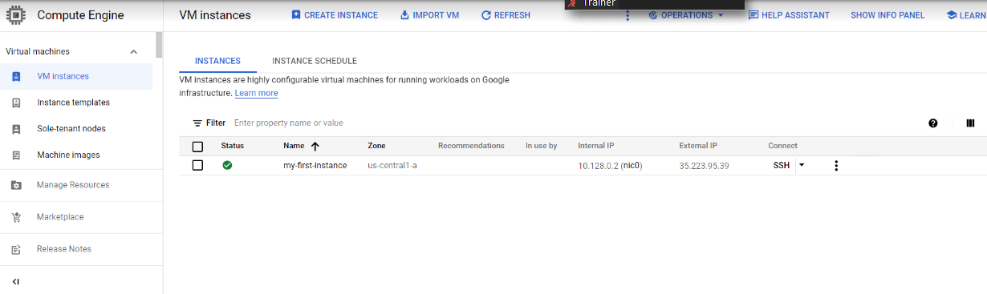

**Q1) Create a Linux VM and Host a sample website**

**🡪** Initially Create a docker and copy all file into a container using docker command

🡪Then create a VM by giving container configuration path into the container image

🡪URL : https://github.com/learning-zone/website-templates

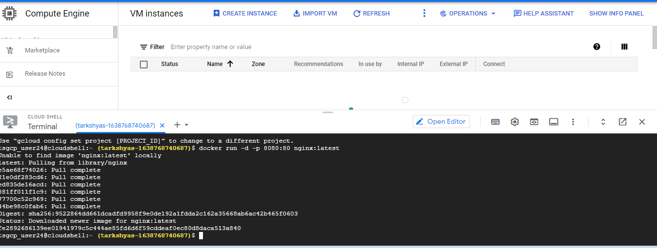

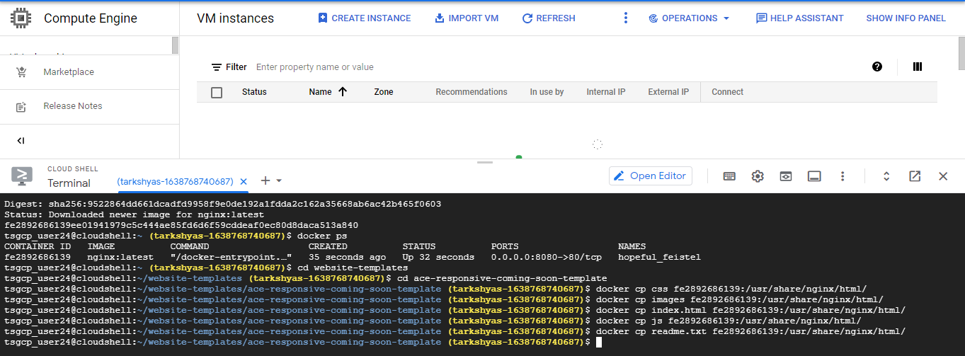

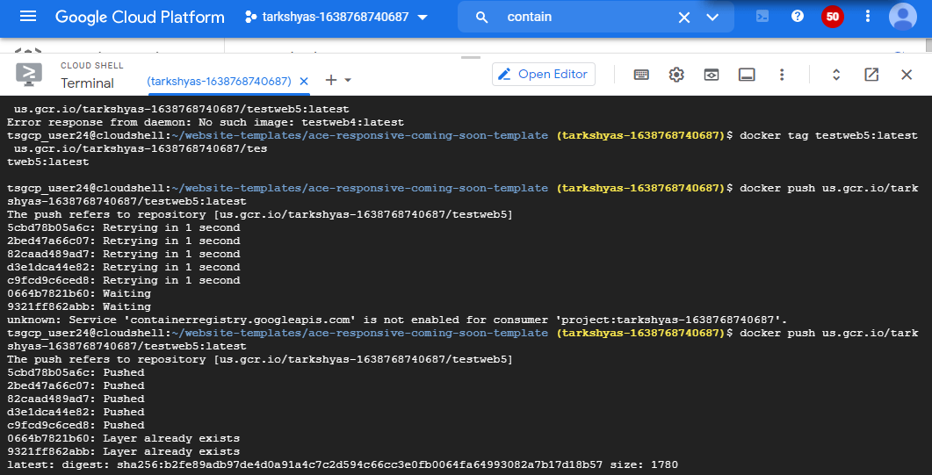

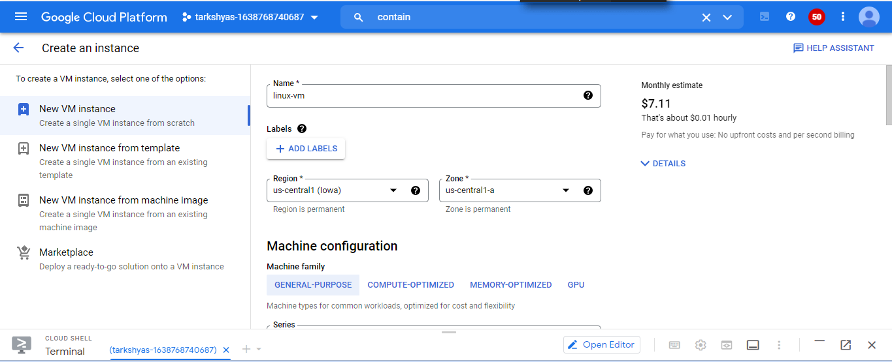

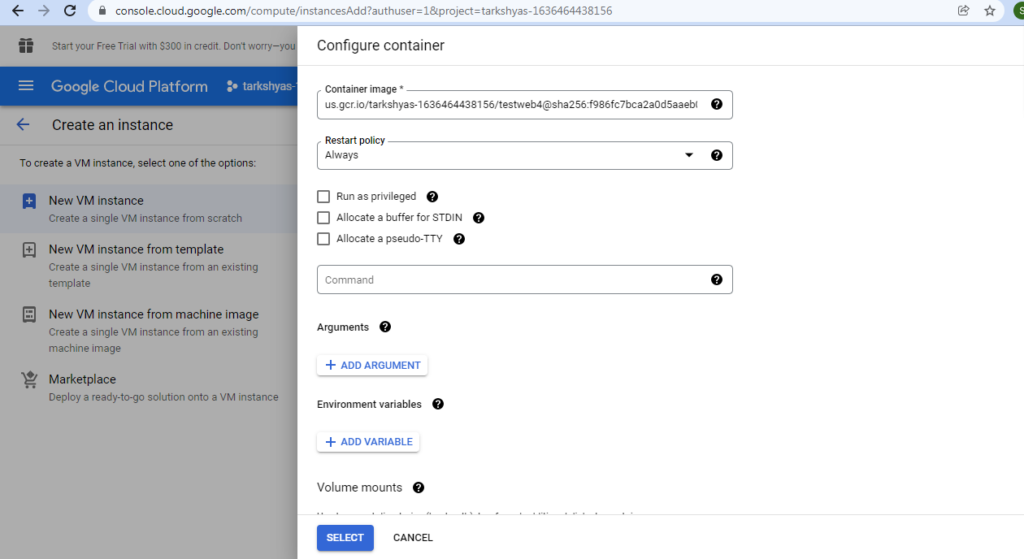

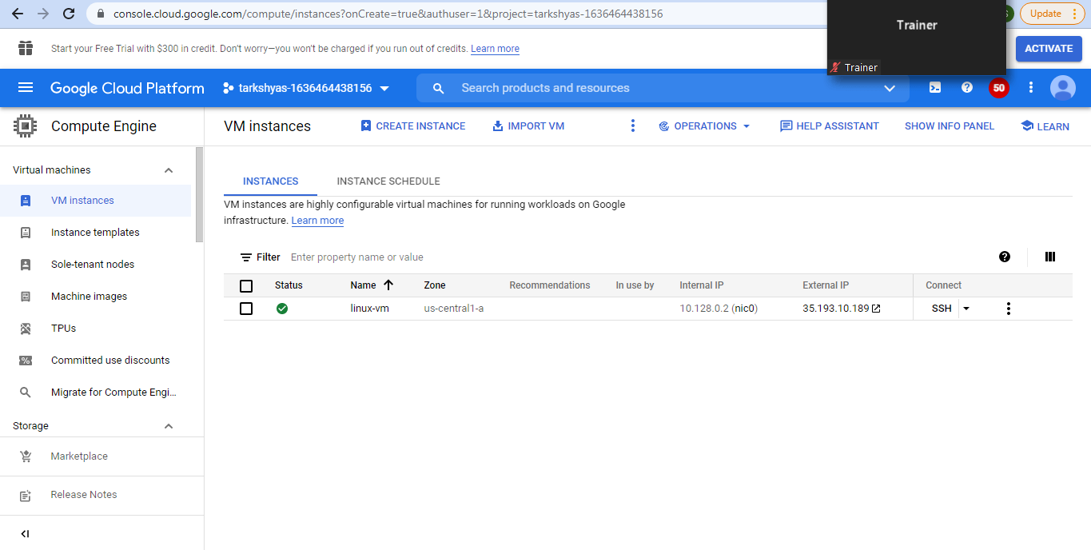



**Q8) Cloud DNS:**

* First create a Domain
* Then create a VM
* Then enable cloud DNS and add the domain server name into it.
* Then copy all the resource data into domain server

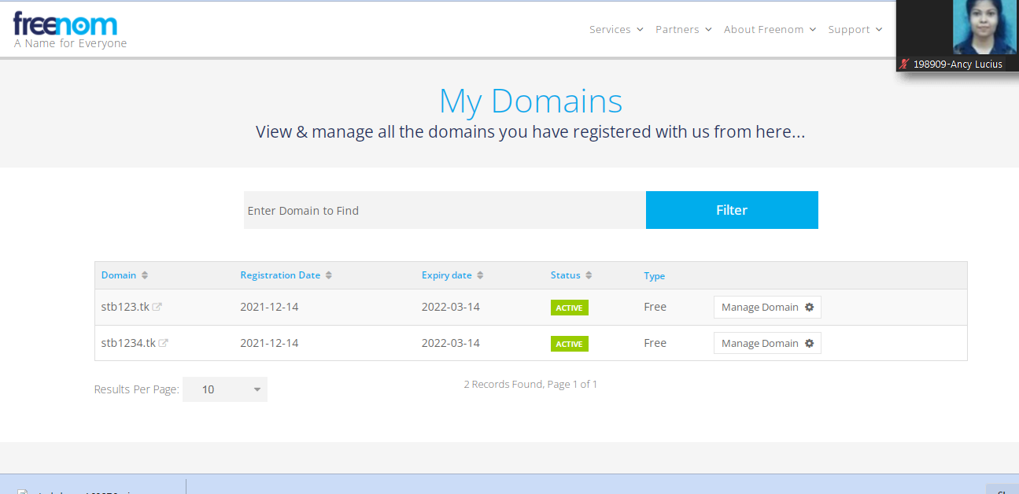

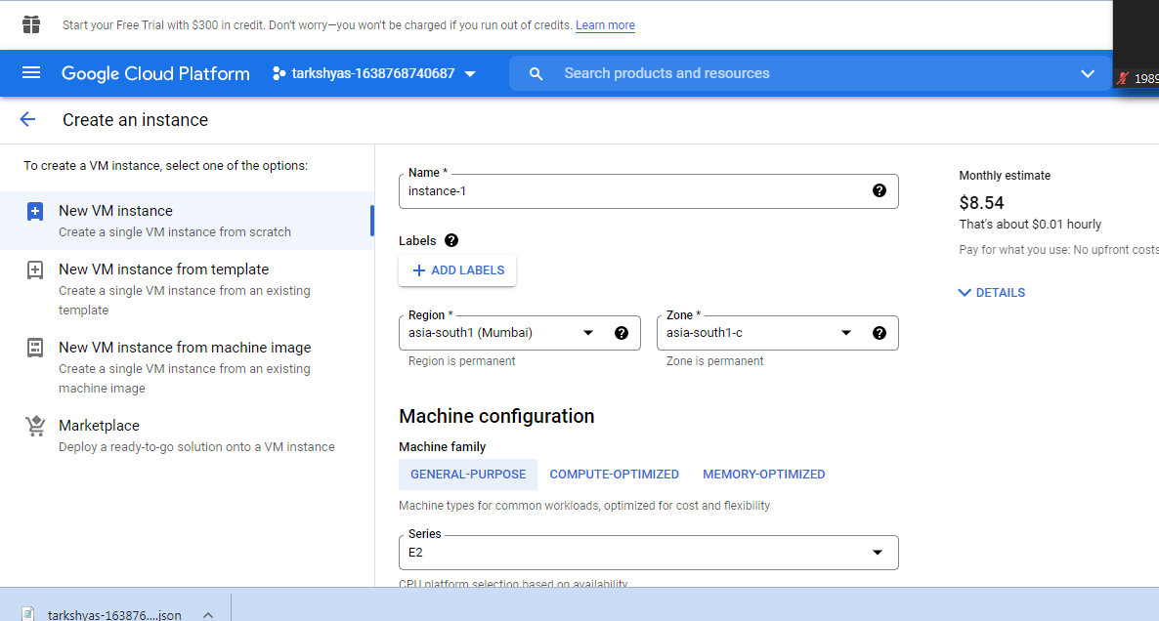

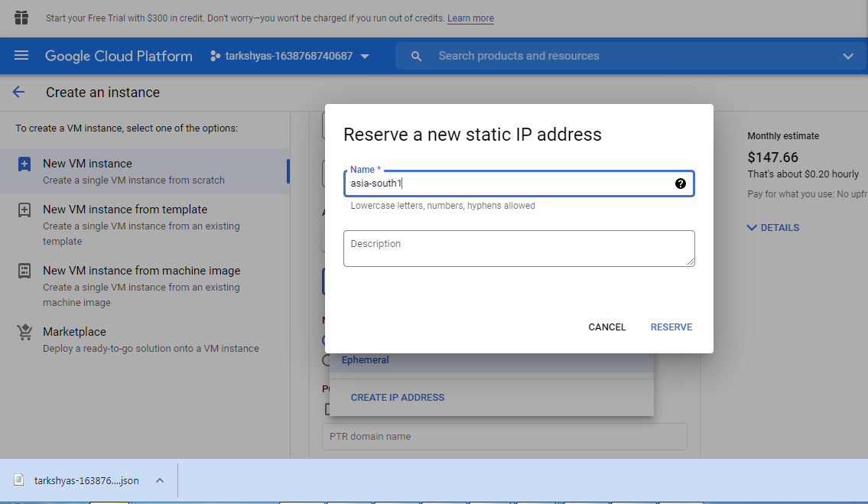

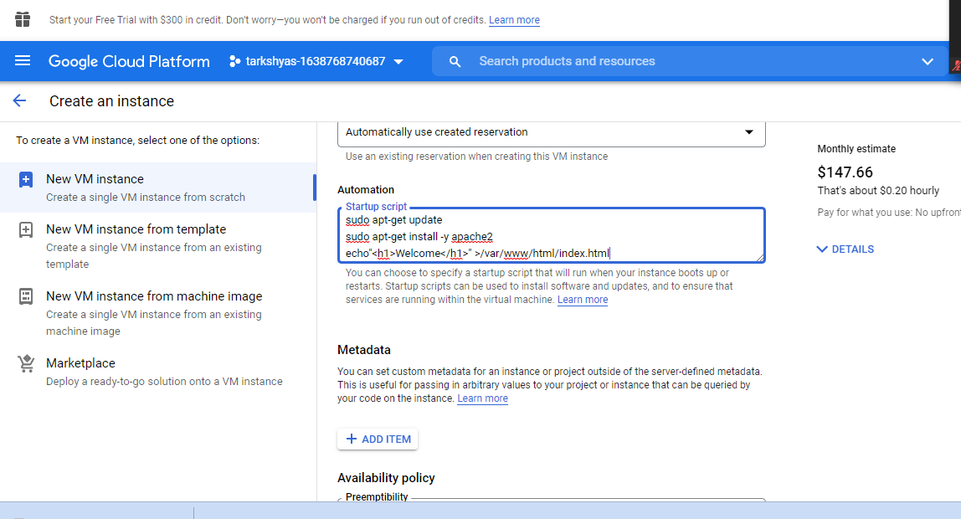

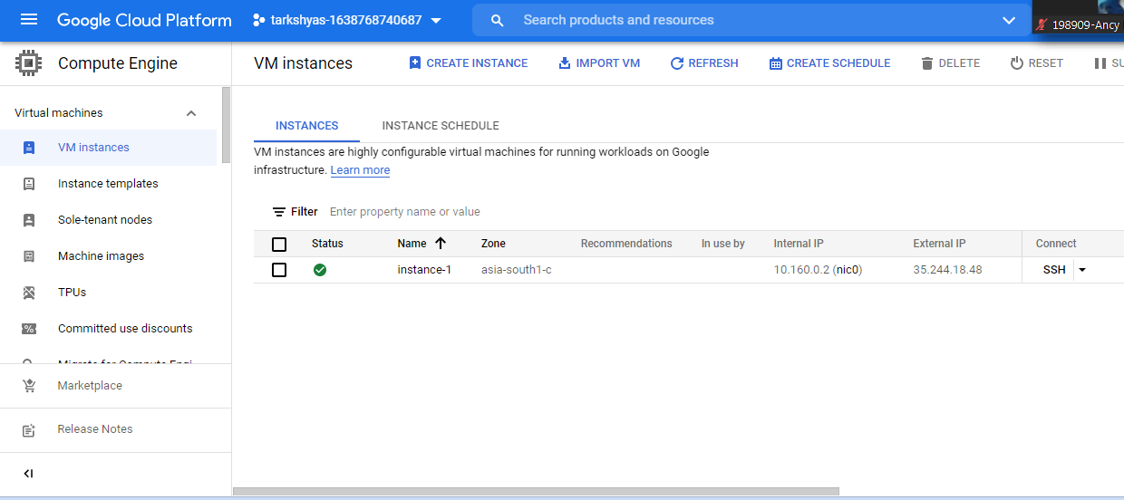

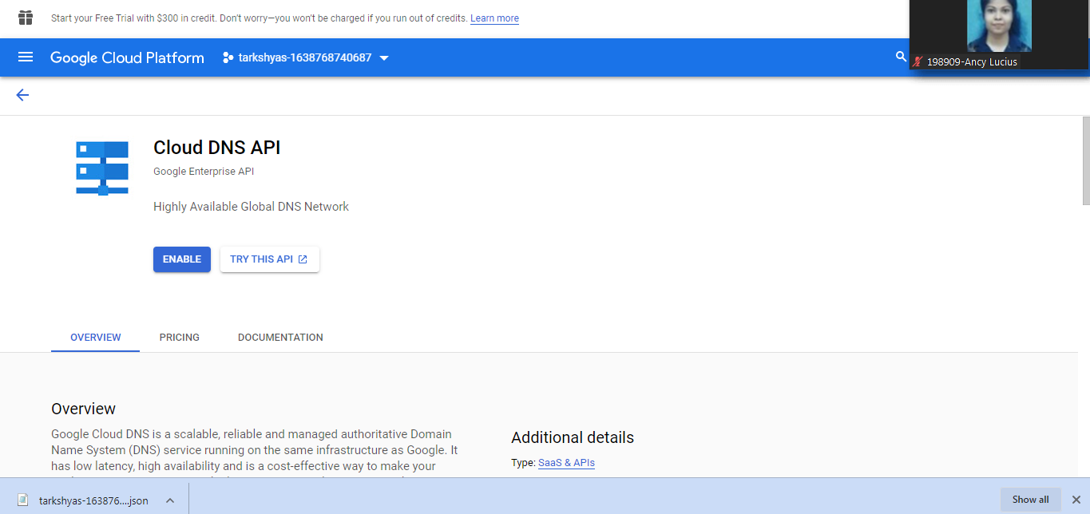

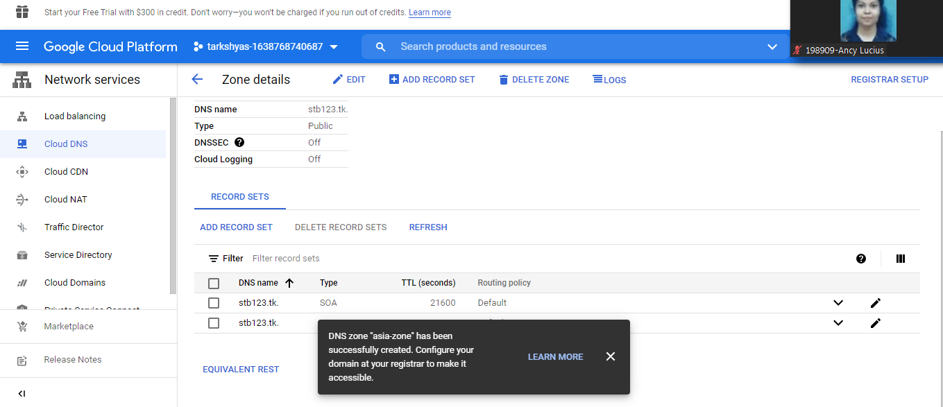

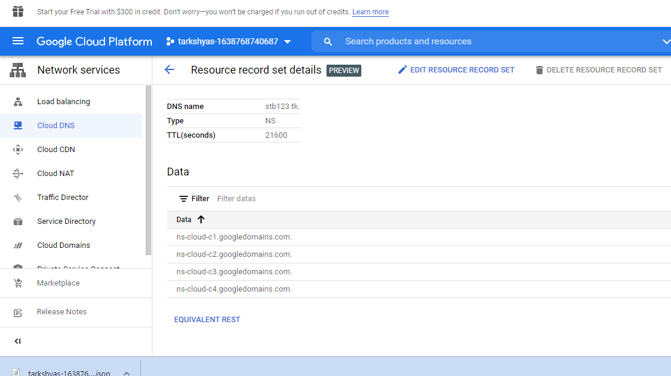

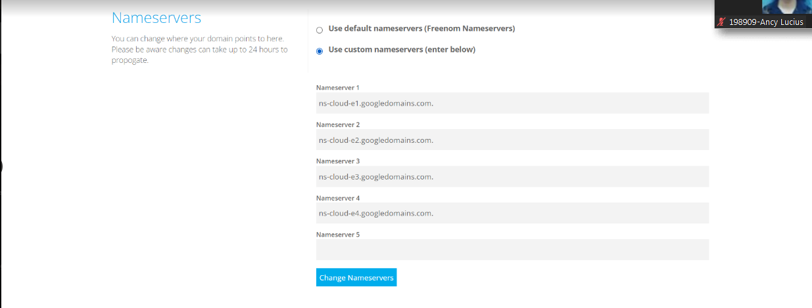

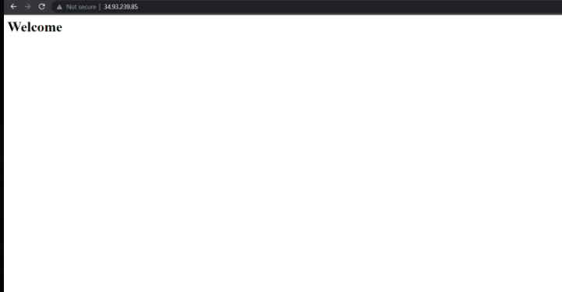

**Q12) BiqQuery:**

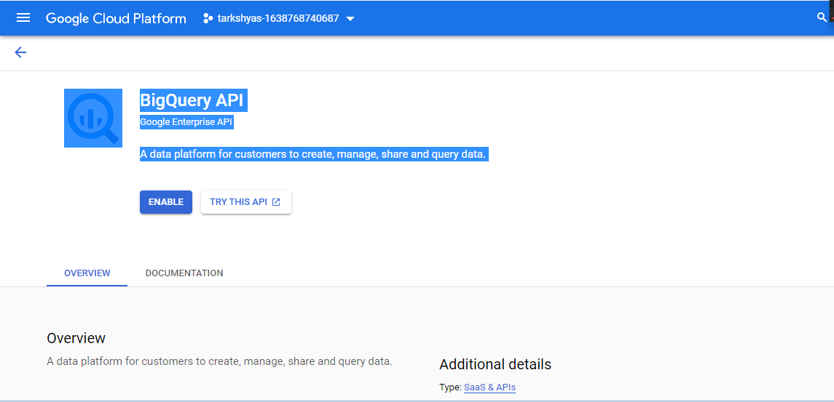

**🡪**Enable BigQuery

-->For Adding file into the query first upload file into cloud storage

🡪We can also get the file from drive and Bigtable.

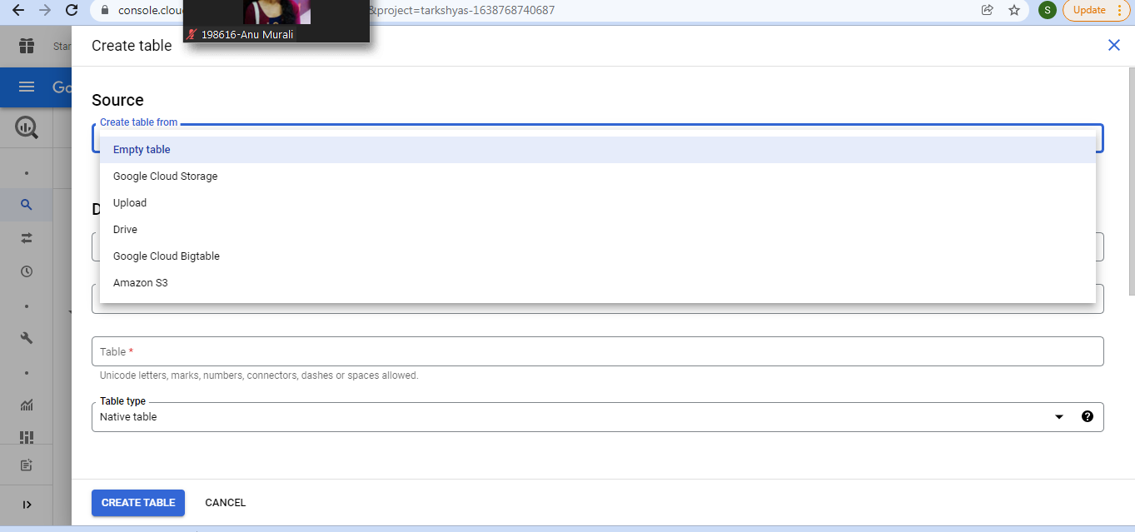

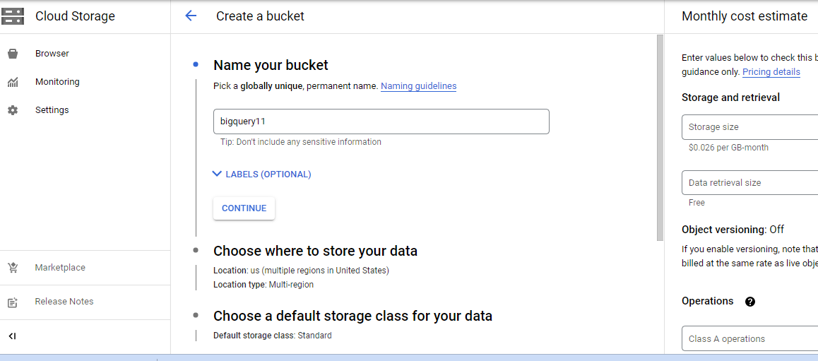

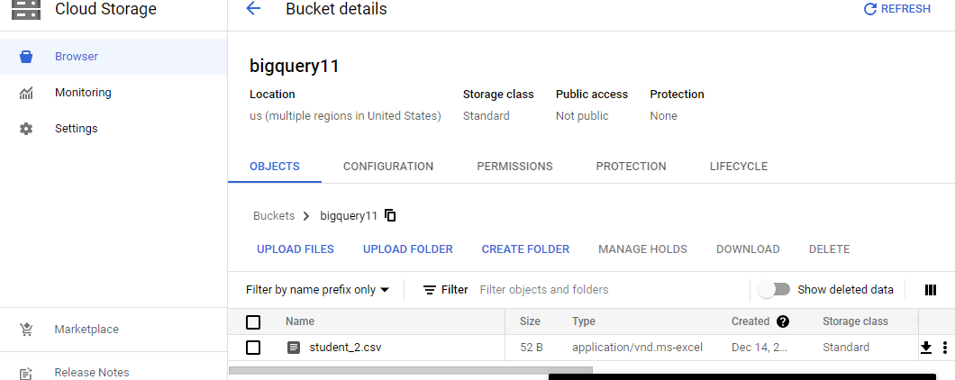

🡪Every table values are added to the bigquery and performed each operations on it.

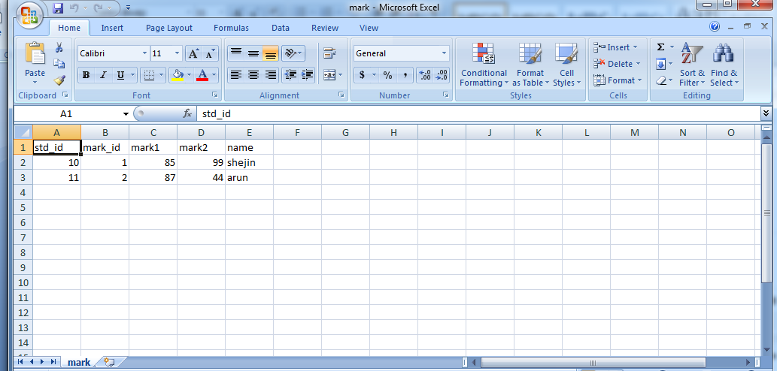

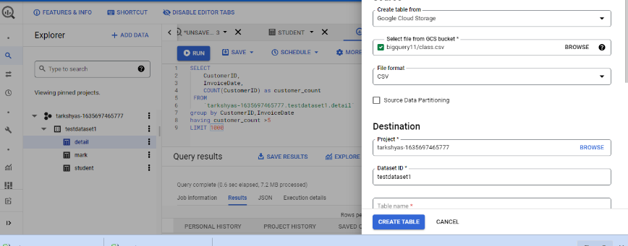

* JOIN operation

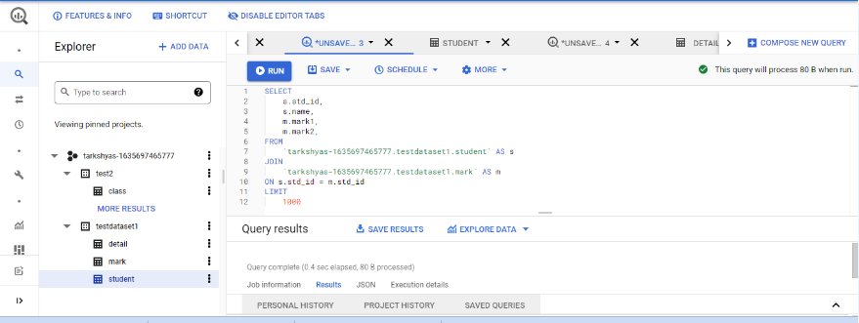

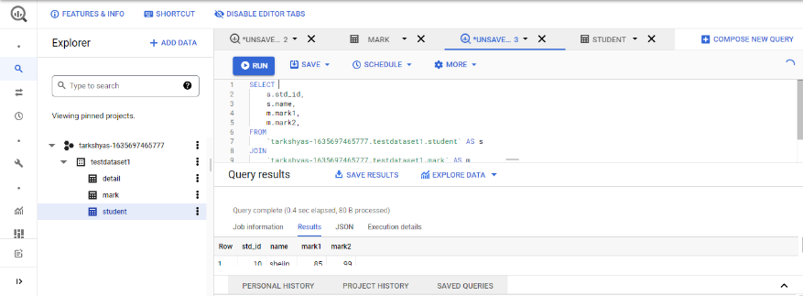

* Group,Order operations on data.

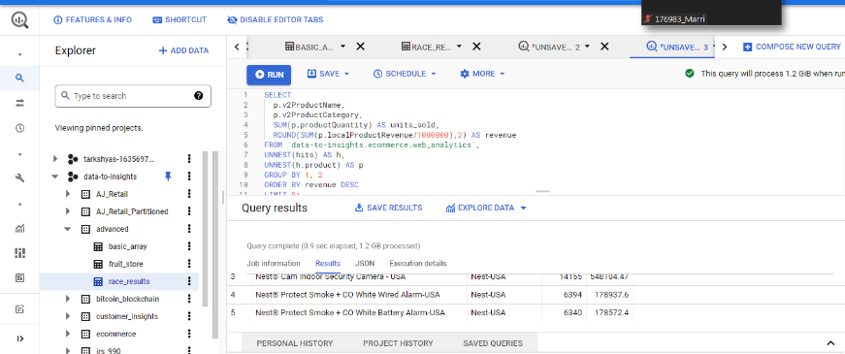

* Clustering and Partitioning in table values.

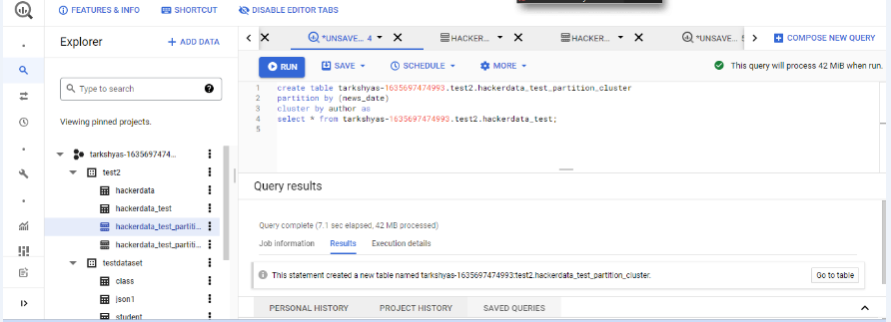

* Machine Learning Model In BigQuery:

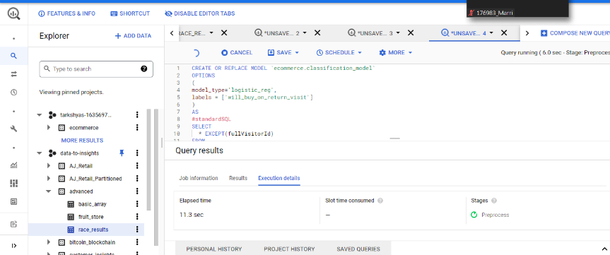

**Q3) App Engine Using Standard Environment:**

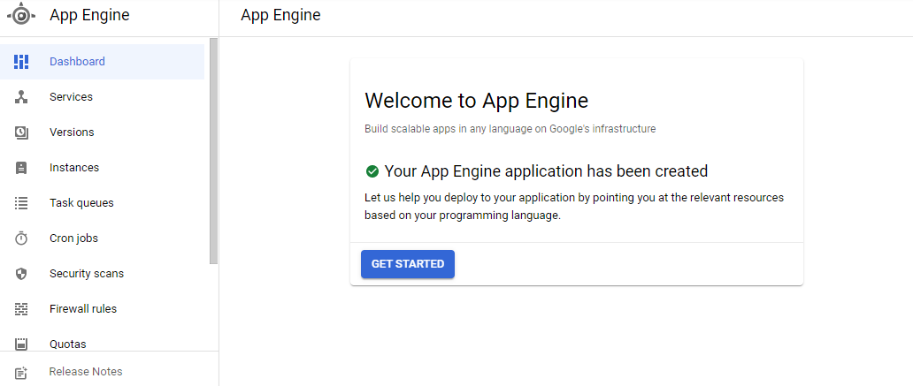

🡪First clone the github file into cloud shell

🡪URL: https://github.com/amunategui/rapid-prototyping-app-engine-yelp

🡪Then change directory to the file

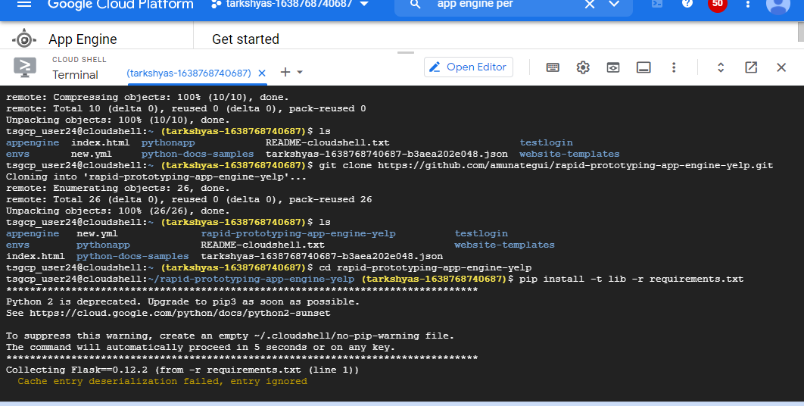

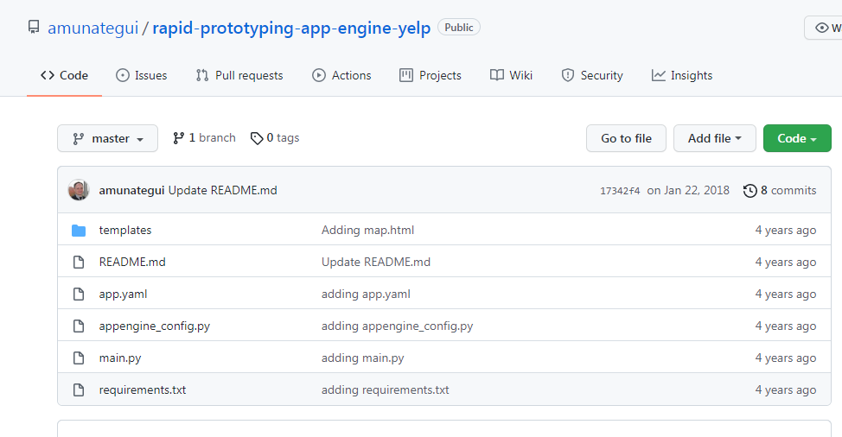

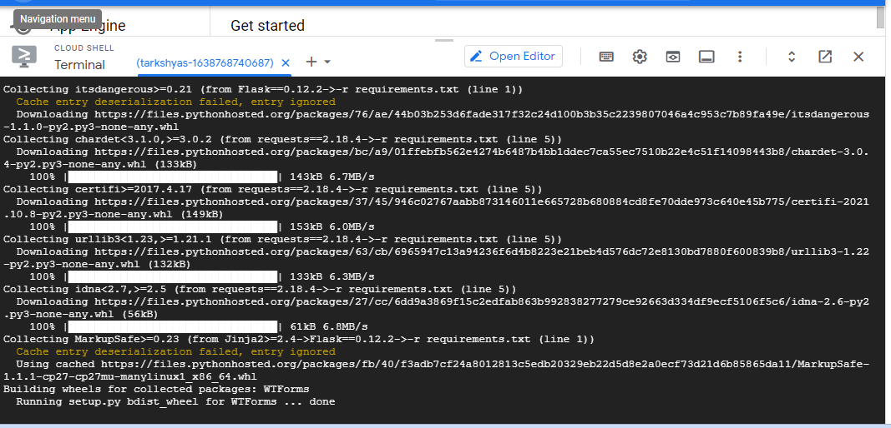

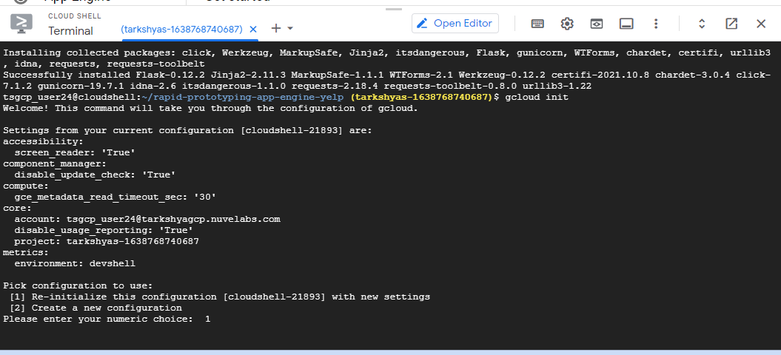

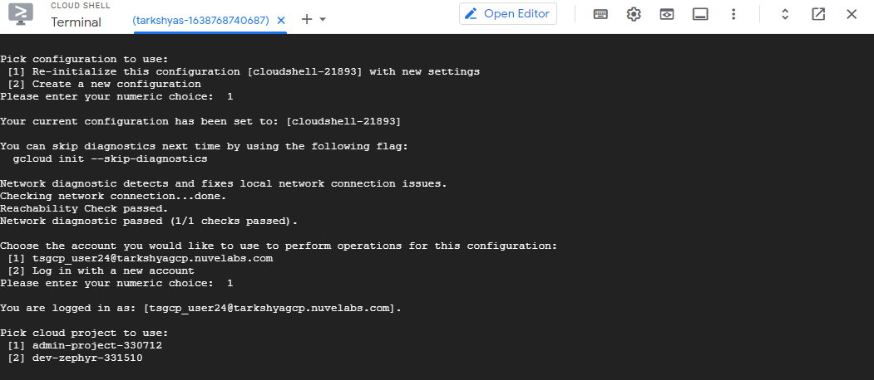

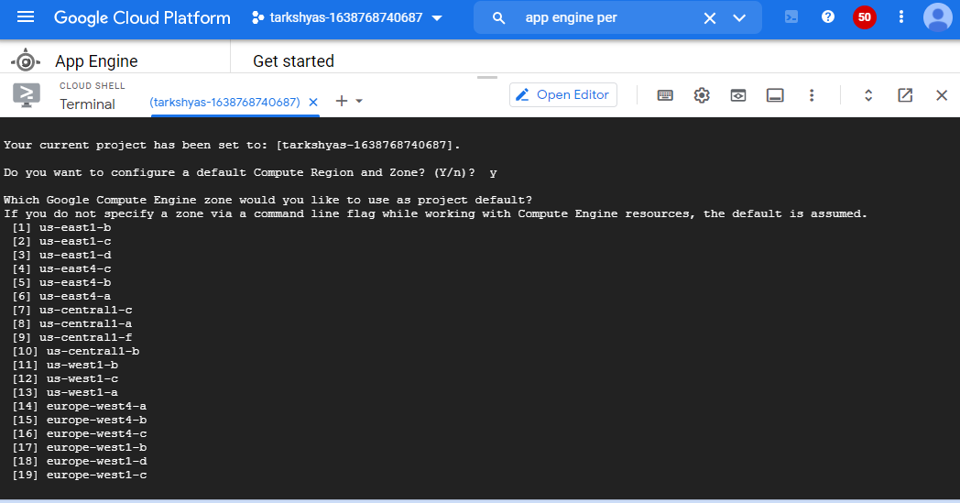

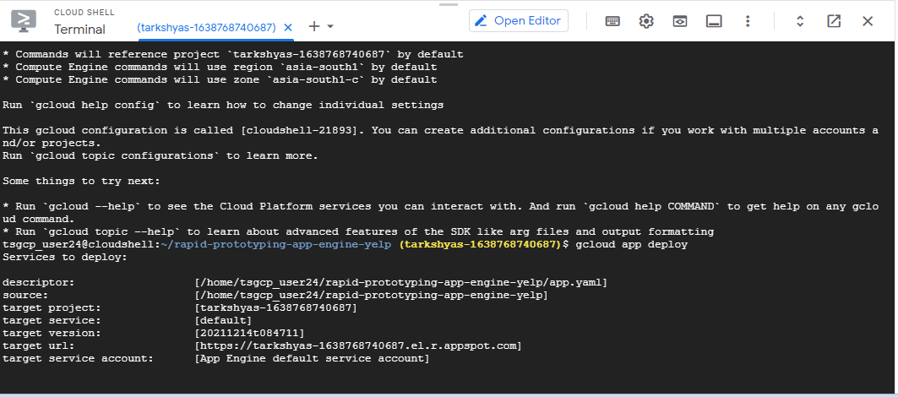

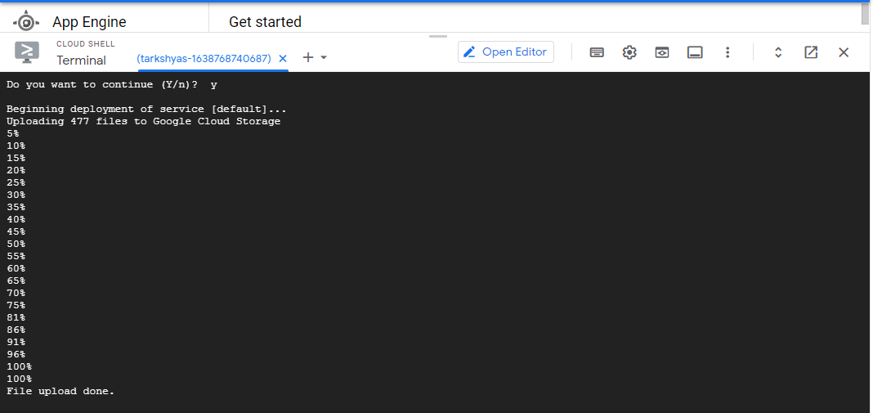

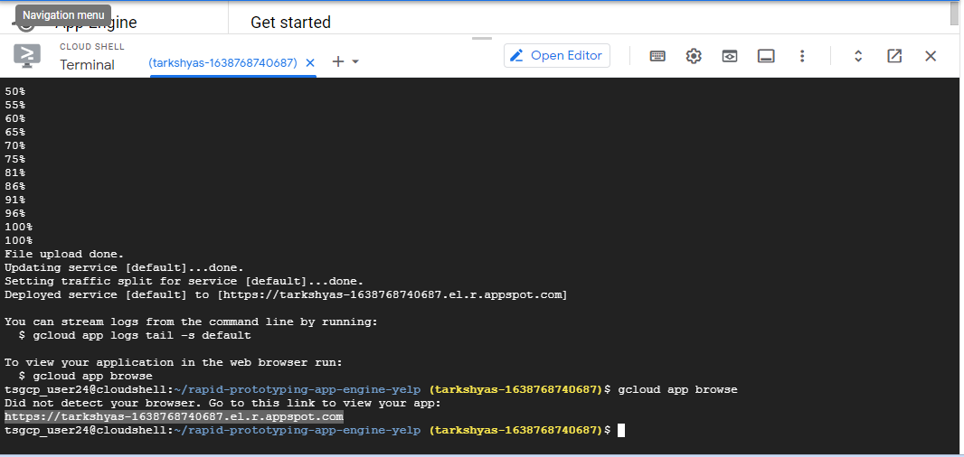

**🡪For Getting the webpage**

* **Enter command gcloud app browser: it will give the url.**

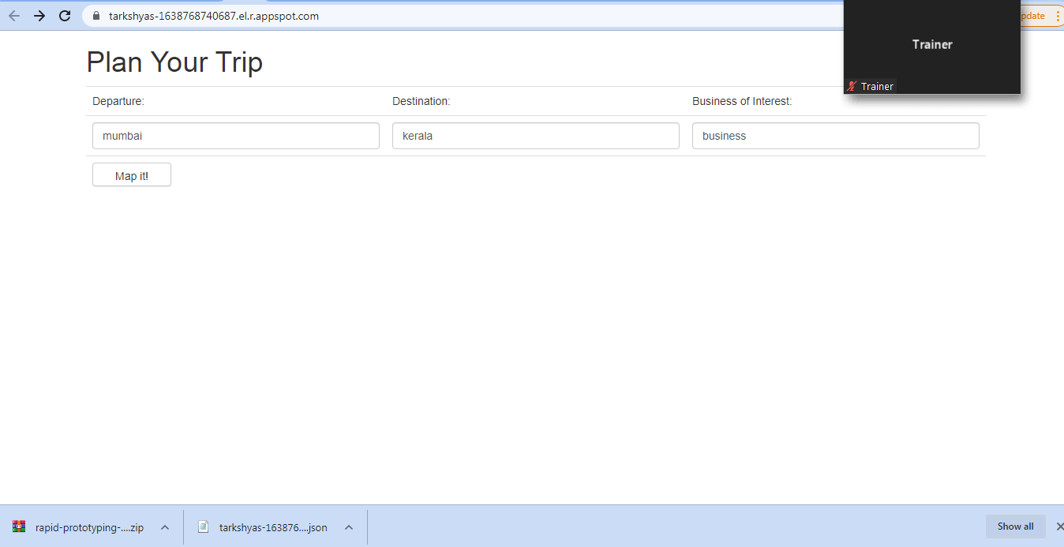

**Q4) App Engine in Flexible:**

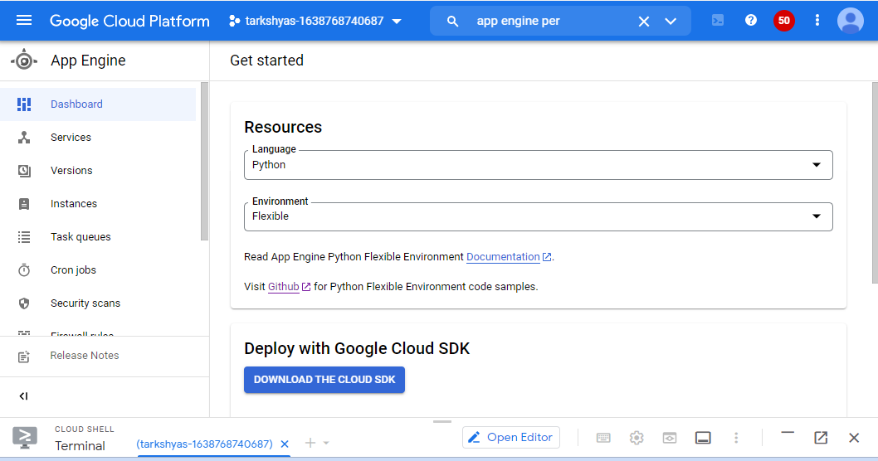

* Here we can scaling the environment according to the user.
* Here also same steps that we used for deploying appengine using standard environment are used
* URL : https://github.com/amunategui/rapid-prototyping-app-engine-yelp



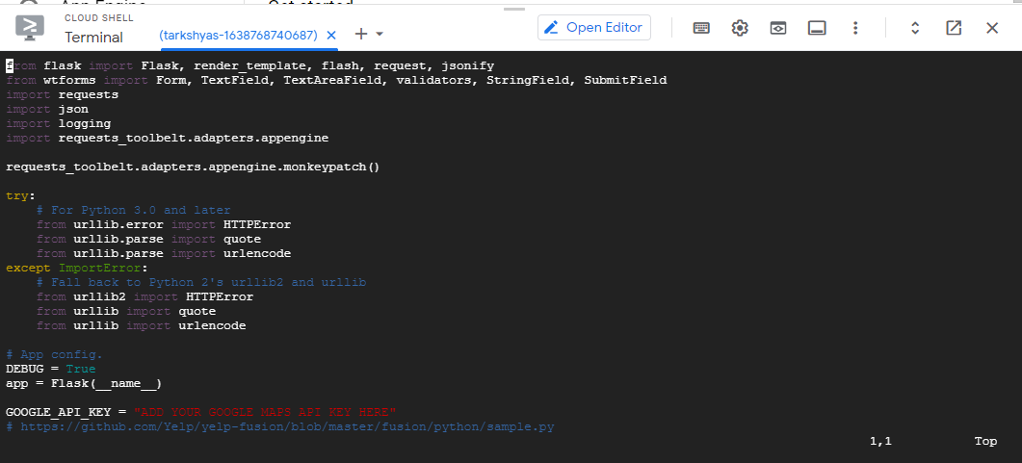



🡪Gcloud app deploy command is used for deploying.





